The long-term consequences of long-term disadvantage
Report to the Northern Powerhouse Partnership

Katie Beynon
Dave Thomson
October 2022

Executive Summary

- We look at how long-term educational and economic outcomes for a cohort of pupils vary by the length of time they were eligible for free school meals (FSM) at school. Of particular interest is the group of pupils who spent at least 80% of school terms eligible for FSM – the long-term disadvantaged group (LTD).
- Nationally, around 8% of individuals were long-term disadvantaged at school. London had the greatest proportion (15%) followed by the North East (12%) and North West (11%). The East, South West and South East had the lowest proportion (4%).
- Long-term disadvantage was associated with other school-age characteristics known be related to lower educational outcomes. Long-term disadvantaged individuals had lower attainment at Key Stage 2, and a higher incidence of Special Educational Needs (SEN) identification.
- Nationally, LTD pupils were around 30% less likely than those who had never been eligible for FSM to be observed in sustained study or employment at age 22 (61% of LTD pupils vs 85% of never FSM) and around six times more likely to be receiving workless benefits (30% of LTD pupils vs 5% of never FSM pupils).
- Their qualification rates were also much lower, and they were much less likely to progress to degree-level study. (37% of LTD pupils achieved the equivalent of at least 2 A-levels by age 22 compared with 71% of never FSM pupils. And 24% of LTD pupils were participating in degree-level study at age 21 compared with 46% of never FSM pupils).
- Gaps in outcomes between LTD and never FSM pupils varied considerably by ethnicity. For example, 24% of LTD White British pupils achieved the equivalent of at least 2 A-levels by age 22 compared with 70% of White British never FSM pupils – a gap of 46 percentage points. For Chinese pupils, the equivalent figures are 78% and 89% - a gap of 11 percentage points.
- Outcomes for LTD pupils in London were substantially better than elsewhere. For example, 69% of LTD pupils in London were observed in sustained study or employment at age 22 compared with 54% in the North East (the region with the lowest outcomes for LTD pupils).
- When looking at outcomes separately by ethnic grouping, London still led the other regions in qualification rates and progression to degree-level study, albeit by a smaller margin. This suggests than much, but not all, of London’s lead is related to the ethnic composition of its LTD pupils.
- Around 33% of LTD pupils in the capital were from an ethnic background where disadvantage has been shown by previous research to have a high impact on educational outcomes (mostly White British, but also Black Caribbean and Mixed White and Black Caribbean) compared with 94% of LTD pupils in the North East.

The long-term consequences of long-term disadvantage

Acknowledgements
This work contains statistical data from ONS which is Crown Copyright. The use of ONS statistical data in this work does not imply the endorsement of ONS in relation to the interpretation or analysis of the statistical data. This work uses research datasets which may not exactly reproduce National Statistics aggregates.

1. Introduction
We’ve been writing for a number of years about the relationship between attainment and the amount of time pupils have been eligible for free school meals (FSM). We’ve also written about how this relationship differs between pupils from different ethnic backgrounds.
We now go beyond this analysis to examine the longer-term outcomes of long-term disadvantage. This includes post-school qualifications, employment and earnings. We focus on a small number of key outcomes in this report, with additional outcomes provided as an Appendix.
There are three recent pieces of work in this domain that this study aims to build upon.
The first is the IFS’s recently published review of existing work on education inequalities. They looked at how education outcomes vary by gender, socio-economic status, ethnicity and region. They then examined how differences in education outcomes are related to differences in life outcomes.
The second and third are pieces of analysis published by the ONS looking at long-term outcomes for disadvantaged pupils.
Much of this work looked at variation in outcomes by pupils’ eligibility for free school meals (FSM) at a single point in time (for example, in the year GCSEs were taken). We build on this by considering pupils’ FSM eligibility over their entire school careers. Additionally, while they were primarily concerned with pupil disadvantage in general terms, it is the persistence of disadvantage over time that we are concerned with.

2. Data

2.1. Background
We use linked data from the National Pupil Database (NPD) and Longitudinal Educational Outcomes (LEO) dataset.
NPD provides an almost complete history of enrolments in state-funded schools in England, together with data on attainment, absence and exclusions. It has also been linked to other educational datasets such as
- the National Client Caseload Information System (NCCIS), which records activities undertaken in the first two years post-16
- the Local Authority Alternative Provision Census, which records educational provision paid for by local authorities but delivered outside the state-funded school system (e.g. independent schools)
- the Young Persons Matched Administrative Dataset (YPMAD), which records qualifications held at Level 3 of the National Qualifications Framework (A level and equivalent) and below from age 16 upwards.
The LEO dataset provides details of labour market participation including annual earnings, spells of employment and state benefits received. Details of qualifications/ courses studied post-16 within the further and higher education sectors are also available via the Individualised Learner Record (ILR) and Higher Education Statistics Agency (HESA) student record. These datasets cover the UK apart from ILR which is limited to England.

2.2. Defining cohorts
The aim of the project is to examine the longer-term outcomes of being disadvantaged while at school. Disadvantage is defined as the percentage of terms pupils are observed in School Census as being eligible for free school meals (FSM) from Reception to Year 11 (age 5 to 16).
This means we need to observe FSM history over a twelve year period. As the first School Census took place in January 2002, the oldest cohort we include are those in Reception that year and who would have reached the end of compulsory schooling (Year 11) in 2013. These pupils were born between 1st September 1996 and 31st August 1997. We also include the two cohorts born between 1st September 1997 and 31st August 1999.
We include in the cohorts all pupils we observe from Year 7 (age 12) to Year 11 (age 16) in state-funded schools (mainstream, special, alternative provision) and young people in local authority alternative provision. This means we do not include pupils who were observed attending state-funded primary schools but not secondary schools. These pupils may have entered the independent sector or migrated to other parts of the UK or overseas.
We label each cohort with the year in which they would have been expected to finish Key Stage 4.

2.3. Defining outcomes
We create a set of post-16 outcome measures covering education and labour market participation for each academic year post compulsory schooling.
The measures cover
- Highest level of qualification, sourced from YPMAD for qualifications up to NQF level 3 and from ILR and HESA for qualifications at NQF level 4 and above
- Achievement of a grade C/4 in GCSE English
- Achievement of a grade C/4 in GCSE maths
- Recorded in custody in NCCIS
- Number of months recorded as not in employment, education and training (NEET) in NCCIS
- Enrolled on a qualification at NQF level 6 in a higher education institution
- Enrolled on a qualification at NQF level 6 in a higher education institution belonging to the Russell Group
- Earnings from employment and self-employment
We also calculate the number of days each year we observe individuals participating in various activities. These are
- Number of days employed
- Number of days in receipt of workless benefits
- Number of days enrolled in schools
- Number of days enrolled in further education (colleges, work-based learning and other providers)
- Number of days enrolled in a higher education institution
We use the measures based on number of days to create a measure of a sustained destination. We define a sustained positive destination as being continuously enrolled in education (school, further education or higher education) or in employment for 180 days or more.
Daily earnings are calculated by dividing annual earnings by days employed (where days employed are observed). We ignore the top and bottom 0.5% of values as these seem implausible. Note that data on hours worked is not currently available.
The key outcomes we summarise in this report are
- Proportion of individuals observed in a sustained positive destination at age 22, i.e. observed either in education (schools, further education or higher education institutions) or employment for at least 180 days
- Proportion of individuals in receipt of workless benefits for at least 180 days at age 22
- Average earnings from employment and self-employment at age 22
- Proportion of individuals by highest qualification level achieved by ages 18, 19, 20, 21 and 22
- Proportion of individuals enrolled in a higher education institution at age 21
Further outcomes are provided in the Appendix.

2.4. Attrition
Although administrative data doesn’t suffer from sample attrition in the same way as survey data it nonetheless exists. Some individuals cease to be observed in any of the data sources. This may arise due to emigration, death or being economically inactive. However, these events are unobserved. Table 1 shows the possible extent of attrition within the data used.
Table 1: A summary of attrition by cohort
KS4 Year | % observed after KS4 year | % observed in 2019 | % with 2019 earnings data | Total Cohort (000s)
2013 | 99% | 92% | 74% | 604.8
2014 | 99% | 93% | 72% | 592.1
2015 | 99% | 94% | 71% | 587.3

In each cohort, over 99% of individuals are observed in at least one year following Key Stage 4 in at least one data source. This is the group we include in our analysis.
However, 8% of the 2013 cohort was not observed in 2019. 74% of the 2013 cohort were observed to have earnings data in 2019.
Attrition is related to gender. 10% of boys from the 2013 cohort were not observed in 2019 compared to 5% of girls. Among the boys, the most disadvantaged were more likely (12%) than those never eligible for free school meals (9%) to not be observed in 2019. This is summarised in Table 2.
Table 2: A summary of attrition from the 2013 Key Stage 4 cohort by gender
 | % observed in 2019 |  | Total Cohort (000s)
% terms FSM | Boys | Girls | Boys | Girls
Never FSM | 91% | 95% | 207.2 | 197.4
<=25% | 90% | 95% | 27.2 | 25.9
25% to 50% | 89% | 95% | 24.6 | 23.0
50% to 80% | 88% | 95% | 25.6 | 24.4
80% or more | 88% | 94% | 25.3 | 24.3
Total | 90% | 95% | 309.9 | 294.9

Attrition is also related to region. Generally, those from the 2013 who attended schools in the North East of England were most likely to be observed in 2019 and those in London were least likely. This is summarised in Table 3.
Table 3: A summary of attrition from the 2013 Key Stage 4 cohort by the region in which individuals attended school at age 16. Attrition is shown separately for those who were never eligible for free school meals (FSM), those who were eligible for 25% of school terms or fewer, and those who were eligible for 80% of school terms or more. Attrition rates for those who were eligible for more than 25% but fewer than 80% of terms are omitted.
 | % observed in 2019,  by % terms eligible for FSM |  |  | Total cohort (000s),  by % terms eligible for FSM
Region | Never | <=25% | 80% or more | Never | <=25% | 80% or more
North East | 95% | 94% | 93% | 17.9 | 2.9 | 3.7
East Midlands | 93% | 94% | 91% | 37.8 | 4.6 | 3.0
North West | 94% | 93% | 92% | 53.1 | 7.2 | 9.2
Yorkshire and the Humber | 93% | 93% | 91% | 40.2 | 6.0 | 5.4
West Midlands | 93% | 93% | 91% | 43.5 | 6.3 | 6.6
South West | 93% | 93% | 92% | 44.4 | 5.0 | 2.6
South East | 92% | 92% | 90% | 72.0 | 7.8 | 3.7
East | 92% | 92% | 90% | 50.5 | 5.9 | 3.0
London | 90% | 92% | 90% | 45.3 | 7.9 | 12.5

3. Results

3.1. Context

Distribution of disadvantage
Table 4 summarises the number of pupils in the three Key Stage 4 cohorts by disadvantage.
Table 4: A summary of the 2013, 2014 and 2015 end of Key Stage 4 cohorts by disadvantage. The cohort size has been adjusted to only include those individuals who were observed in at least one year following the end of Key Stage 4. This is 99% of the initial cohort.
 | Key Stage 4 cohort
% terms FSM | 2013 | 2014 | 2015
Cohort size (000s) | 599.3 | 586.3 | 581.3
Never FSM | 67% | 67% | 67%
<= 25% | 9% | 9% | 9%
25% to 50% | 8% | 8% | 8%
50% to 80% | 8% | 8% | 8%
80% or more | 8% | 8% | 8%

We see that the majority of individuals in each cohort, around 67%, were never eligible for FSM whilst at school. There are roughly equal proportions of individuals in each of the other disadvantage groupings. Around 8% of individuals in each cohort were eligible for FSM for at least 80% of their time at school. These are the individuals we refer to as “long-term disadvantaged".

Disadvantage by ethnicity
Disadvantage varies by ethnic background. Table 5 (overleaf) shows the breakdown of individuals in the 2013 Key Stage 4 cohort by ethnicity and disadvantage. Those from Irish Traveller, White Romany, Black African or Bangladeshi backgrounds were most likely to have spent the longest proportion of their school careers eligible for FSM. In contrast, those from a Chinese, Indian, White British or Other White background were most likely to have spent none of their school careers eligible for FSM.

Table 5: A summary of the 2013 Key Stage 4 cohort by ethnicity and disadvantage. Sorted in descending order of the proportion of individuals who were eligible for free school meals (FSM) for at least 80% of terms.
 |  |  |  | % terms eligible for FSM
Ethnicity |  | Cohort size (000s) |  | Never |  | <=25% |  | 25%  to 50% |  | 50%  to 80% |  | 80%+
Traveller of Irish Heritage | <1 |  | 17% |  | 3% |  | 7% |  | 22% |  | 51%
White Romany | 1.1 |  | 32% |  | 8% |  | 16% |  | 16% |  | 28%
Black African | 17.3 |  | 40% |  | 9% |  | 10% |  | 15% |  | 26%
Bangladeshi | 8.0 |  | 34% |  | 14% |  | 14% |  | 17% |  | 22%
Other | 7.8 |  | 48% |  | 8% |  | 11% |  | 13% |  | 20%
Other Black | 3.1 |  | 41% |  | 11% |  | 13% |  | 17% |  | 19%
Mixed White/Black Caribbean | 7.6 |  | 44% |  | 11% |  | 13% |  | 16% |  | 16%
Pakistani | 18.6 |  | 47% |  | 13% |  | 12% |  | 12% |  | 16%
Black Caribbean | 8.6 |  | 46% |  | 14% |  | 13% |  | 14% |  | 13%
Mixed White/Black African | 2.5 |  | 52% |  | 10% |  | 11% |  | 14% |  | 13%
Other Mixed | 7.7 |  | 57% |  | 10% |  | 10% |  | 12% |  | 11%
White Irish | 2.1 |  | 68% |  | 7% |  | 6% |  | 7% |  | 11%
Mixed White/Asian | 4.6 |  | 64% |  | 9% |  | 8% |  | 10% |  | 9%
Not obtained | 6.2 |  | 66% |  | 8% |  | 9% |  | 8% |  | 9%
Refused to say | 3.9 |  | 64% |  | 10% |  | 9% |  | 9% |  | 9%
Other Asian | 7.9 |  | 67% |  | 9% |  | 8% |  | 7% |  | 9%
Other White | 24.9 |  | 71% |  | 7% |  | 7% |  | 7% |  | 8%
White British | 450.9 |  | 70% |  | 9% |  | 7% |  | 7% |  | 7%
Indian | 13.8 |  | 77% |  | 9% |  | 6% |  | 5% |  | 4%
Chinese | 2.4 |  | 83% |  | 6% |  | 5% |  | 4% |  | 3%
Total | 599.3 |  | 67% |  | 9% |  | 8% |  | 8% |  | 8%

Disadvantage by region
Disadvantage also varies by region, as shown in Table 6 (overleaf). Those attending schools in London at age 16 were the most likely to have spent at least some of their school careers eligible for FSM, while those attending schools in the South East were the least likely (47% in London vs 25% in the South East).
London also had the highest levels of long-term disadvantage, with 15% of individuals having spent at least 80% of their time at school eligible for FSM. The North East (12%) and the North West (11%) had the second and third highest levels of long-term disadvantage.

Table 6: A summary of the 2013 Key Stage 4 cohort by the region in which individuals attended school at age 16 and disadvantage. Sorted in descending order of the proportion of individuals who were eligible for free school meals (FSM) for at least 80% of terms.
 |  |  |  | % terms eligible for FSM
Region at age 16 |  | Cohort size (000s) |  | Never |  | <=25% |  | 25%  to 50% |  | 50%  to 80% |  | 80%+
London | 83.2 |  | 53% |  | 9% |  | 10% |  | 12% |  | 15%
North East | 29.8 |  | 60% |  | 10% |  | 8% |  | 10% |  | 12%
North West | 83.8 |  | 63% |  | 9% |  | 8% |  | 9% |  | 11%
West Midlands | 67.9 |  | 64% |  | 9% |  | 9% |  | 9% |  | 10%
Yorkshire and the Humber | 61.0 |  | 65% |  | 10% |  | 8% |  | 8% |  | 9%
East Midlands | 52.4 |  | 71% |  | 9% |  | 8% |  | 7% |  | 6%
East | 68.0 |  | 73% |  | 9% |  | 7% |  | 6% |  | 4%
South West | 58.9 |  | 74% |  | 8% |  | 7% |  | 6% |  | 4%
South East | 94.4 |  | 75% |  | 8% |  | 7% |  | 6% |  | 4%
Total | 599.3 |  | 67% |  | 9% |  | 8% |  | 8% |  | 8%

Other school-age characteristics by disadvantage
Being disadvantaged whilst at school is associated with variations in other characteristics. Table 7 summarises a selection of these for the 2013 Key Stage 4 cohort.
We see that the likelihood of being identified with a special educational need (SEN) whilst at school increases with increasing disadvantage, as does ever having a Statement of SEN. The most disadvantaged members of the cohort were around twice as likely as those who were never eligible for FSM to have had an identified SEN, and around three times as likely to have had a Statement of need. They were also more likely to have spent most of their school careers with an identified SEN, and to have achieved lower scores in Key Stage 2 tests in English and maths.

Table 7: A summary of selected school-age characteristics of the 2013 Key Stage 4 cohort by disadvantage. The percentage of the cohort who were ever identified as having any special educational needs (SEN) at school and as having SEN with a Statement of need are shown, along with the percentage who spent at least 80% of their school careers with an identified SEN (long-term SEN). Average Key Stage 2 scores in English and maths are shown in fractions of National Curriculum levels.
% terms FSM | Cohort size (000s) | % ever SEN | % ever Statement | % long-term SEN | avg KS2 English | avg KS2 maths
Never FSM | 400.0 | 33% | 3% | 5% | 4.64 | 4.68
<=25% | 53.4 | 51% | 5% | 8% | 4.37 | 4.38
25% to 50% | 48.0 | 57% | 7% | 10% | 4.28 | 4.29
50% to 80% | 48.7 | 64% | 8% | 12% | 4.17 | 4.19
80% or more | 49.2 | 69% | 10% | 15% | 4.03 | 4.07
Total | 599.3 | 42% | 5% | 7% | 4.50 | 4.53

3.2. Long-term outcomes

The likelihood of being in a sustained positive destination at age 22

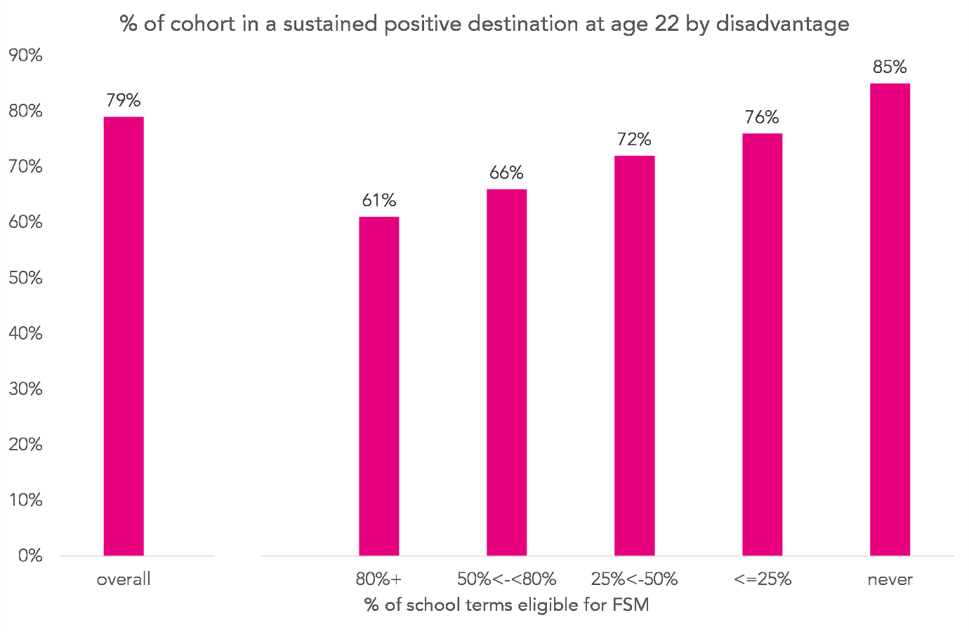
Figure 1: Chart showing the proportion of the 2013 Key Stage 4 cohort who were observed in a positive destination at age 22 by disadvantage. A positive destination is defined as being either in employment or enrolled at an education institution for at least 180 days.
We begin by investigating how the likelihood of being observed in a sustained positive destination at age 22 varies by disadvantage. Figure 1 shows the results of this measure for the 2013 cohort overall and by disadvantage.
We see a clear relationship, with greater disadvantage associated with a lower likelihood of being observed in a sustained positive destination. Long-term disadvantaged pupils were around 30% less likely to go on to a sustained positive destination than those who had never been eligible for FSM (61% vs 85%, respectively), and around 20% less likely than those who had been eligible for FSM for the shortest period (61% vs 76%).
Looking at employment and education separately, the same pattern is evident. Long-term disadvantaged pupils were around 50% less likely to be observed in higher education for a sustained period and around 30% less likely to be in employment for a sustained period than those who had never been eligible for FSM. These results are summarised in Table 8 (overleaf).

Table 8: The proportion of individuals in the 2013 cohort observed in further education (FE), higher education (HE) and employment destinations for at least 180 days in the year they turned 22. Results are shown overall and broken down by disadvantage.
% terms FSM | Cohort size (000s) | Any sustained destination | Sustained FE destination | Sustained HE destination | Sustained employment
Overall | 599.3 | 79% | 7% | 25% | 68%
Never FSM | 400.0 | 85% | 7% | 29% | 72%
<= 25% | 53.4 | 76% | 7% | 19% | 67%
25% to 50% | 48.0 | 72% | 7% | 18% | 63%
50% to 80% | 48.7 | 66% | 7% | 15% | 57%
80%+ | 49.2 | 61% | 6% | 16% | 52%

The likelihood of receiving workless benefits at age 22
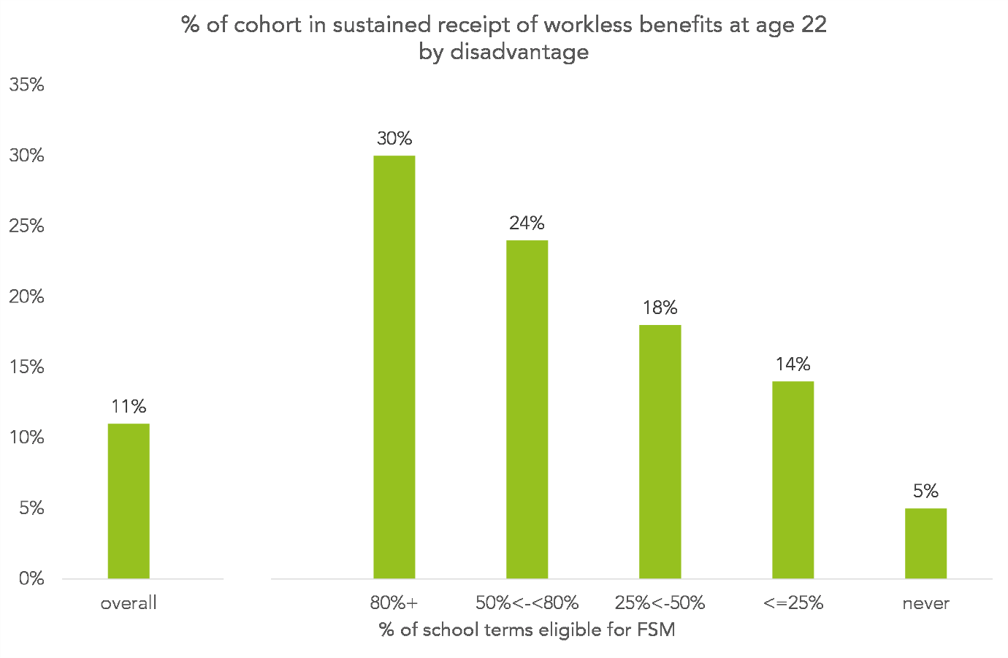
Figure 2: Chart showing the proportion of the 2013 Key Stage 4 cohort who were observed receiving workless benefits at age 22 for at least 180 days. The results are split by disadvantage.
We turn now to a different outcome: receiving workless benefits. This measure is more prone to time-related distortion than our previous measure. At age 22 many who went into higher education have yet to enter the labour market fully. This makes it hard to compare workless benefit rates between groups with different higher education participation.
With this caveat in mind, we show the proportion of the 2013 cohort who were observed receiving workless benefits for a sustained period of time in Figure 2.
Workless benefit rates increased with disadvantage. Almost a third (29%) of long-term disadvantaged pupils were observed receiving workless benefits at age 22. They were around five and a half times more likely to be in this position than those who had never been eligible for FSM (5%), and around twice as likely as those who had been eligible for the shortest period (14%).

Average earnings at age 22
The final labour market outcome we will consider is the average earnings per individual in the year they turn 22. This measure is prone to distortion in the same way as workless benefits – many of those who participated in higher education would not have entered the labour market fully yet. It also suffers from another problem. Because we do not have any data on the number of hours worked, it isn’t possible to distinguish individuals who were paid a high wage over a short period of time from those paid a low wage over a long period of time.
We present average earnings by disadvantage for the 2013 cohort in Figure 3, omitting from our calculation individuals with no earnings data due to attrition or labour market inactivity. We see from Table 9 (overleaf) that the likelihood of being included in the earnings calculation increases with decreasing disadvantage. This is because the least disadvantaged pupils were the most likely to be employed at age 22, as we saw in Table 8.

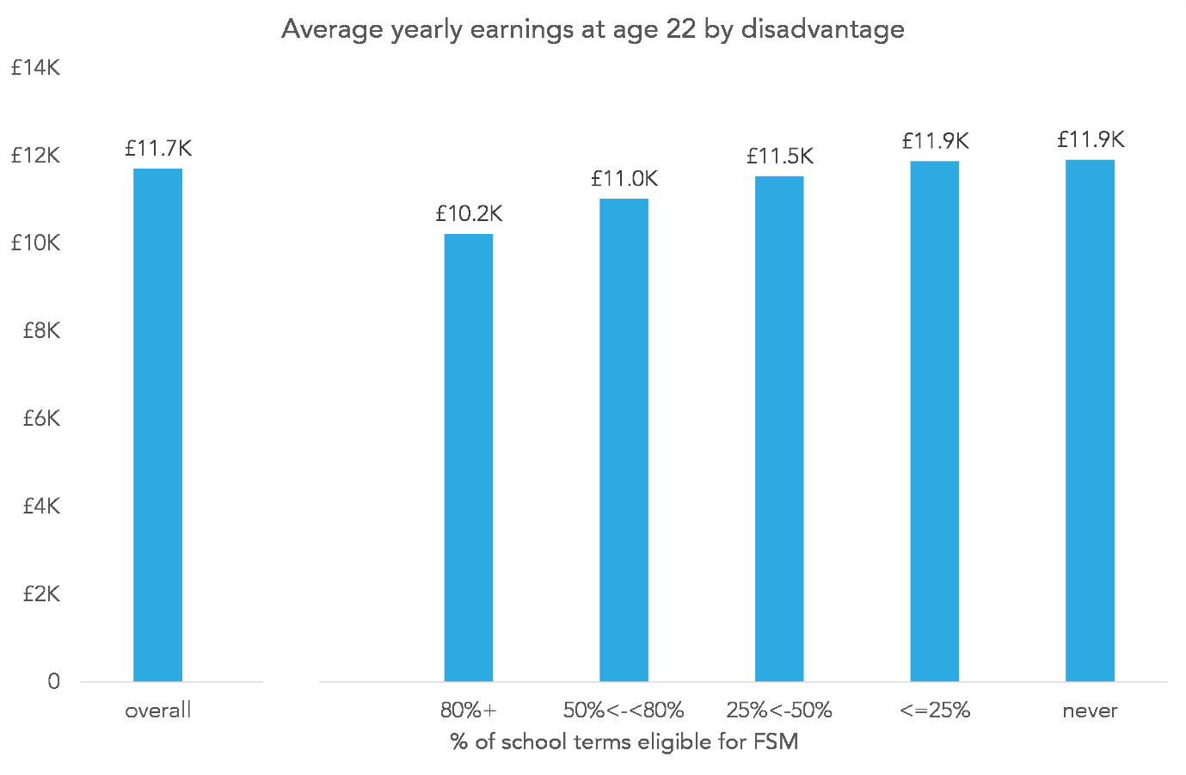
Figure 3: Chart showing the average earnings of the 2013 Key Stage 4 cohort at age 22 by disadvantage. Earnings are from both employment and self-employment. The average is taken over individuals who have earnings > 0, ignoring the top and bottom 0.5% of earners due to implausible values.
We see some relationship between disadvantage and earnings. Long-term disadvantaged pupils went on to earn £1,700 less at age 22, on average, than those who had never been eligible for FSM. This information is of limited use due to the lack of data on hours worked, and because long-term disadvantaged pupils were less likely to be included in the earnings calculation (59% had earnings data compared with 78% of those who had never been eligible for FSM).

Table 9: Percentage of individuals in the 2013 Key Stage 4 cohort for whom we have earnings data at age 22 by disadvantage
 | Cohort size (000s) | % with earnings data at age 22
Overall | 599.3 | 74%
Never FSM | 400.0 | 77%
<= 25% | 53.4 | 73%
25% to 50% | 48.0 | 70%
50% to 80% | 48.7 | 64%
80%+ | 49.2 | 59%

3.3. Educational attainment

Highest qualification level
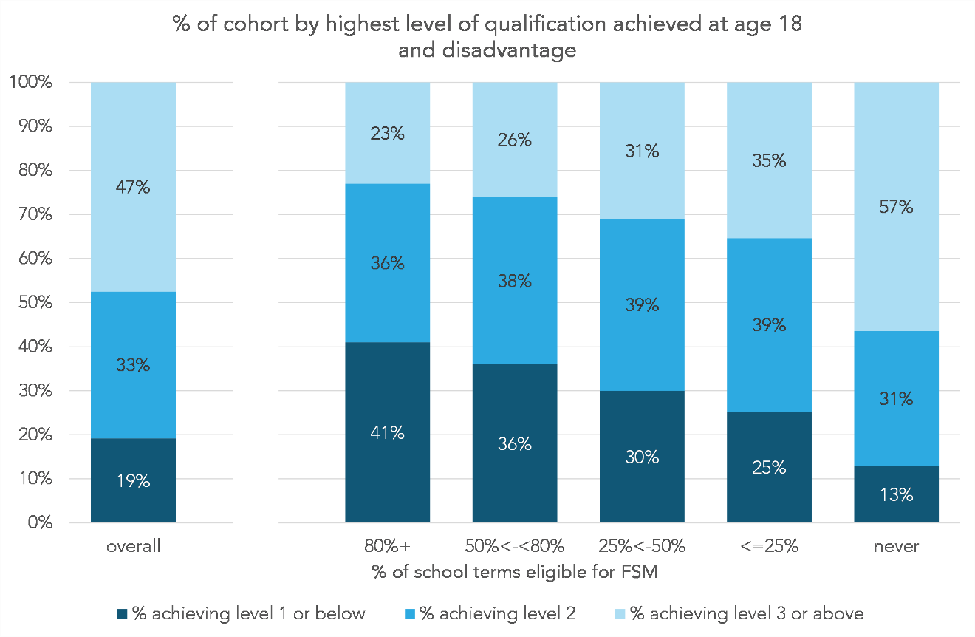
Figure 4: Chart showing the proportion of the 2013 Key Stage 4 cohort who achieved qualifications at NQF levels 1, 2 and 3 by the age of 18. The results are split by disadvantage. NQF level 1 is equivalent to achieving 5 GCSEs at grade 9-1 (A*-G), level 2 to 5 GCSEs at grade 9-4 (A*-C), and level 3 to two A-levels.
Figure 4 shows the highest level of qualification achieved by members of the 2013 cohort by the end of the year they turn 18. Long-term disadvantaged pupils were the most likely to have only achieved qualifications at level 1⁶ or below - around three times more likely than those who were never eligible for FSM (41% vs 13%). They were also the least likely to have achieved qualifications at level 3 and above – less than half as likely as those who were never eligible for FSM (23% vs 57%).
This gap in qualification rates did not narrow in as the individuals aged. Figure 5 shows the proportion of the cohort who had achieved qualifications at NQF level 3 or greater by ages 18 – 22. The highest qualification level achieved by age 22 is shown in full in Figure 6.

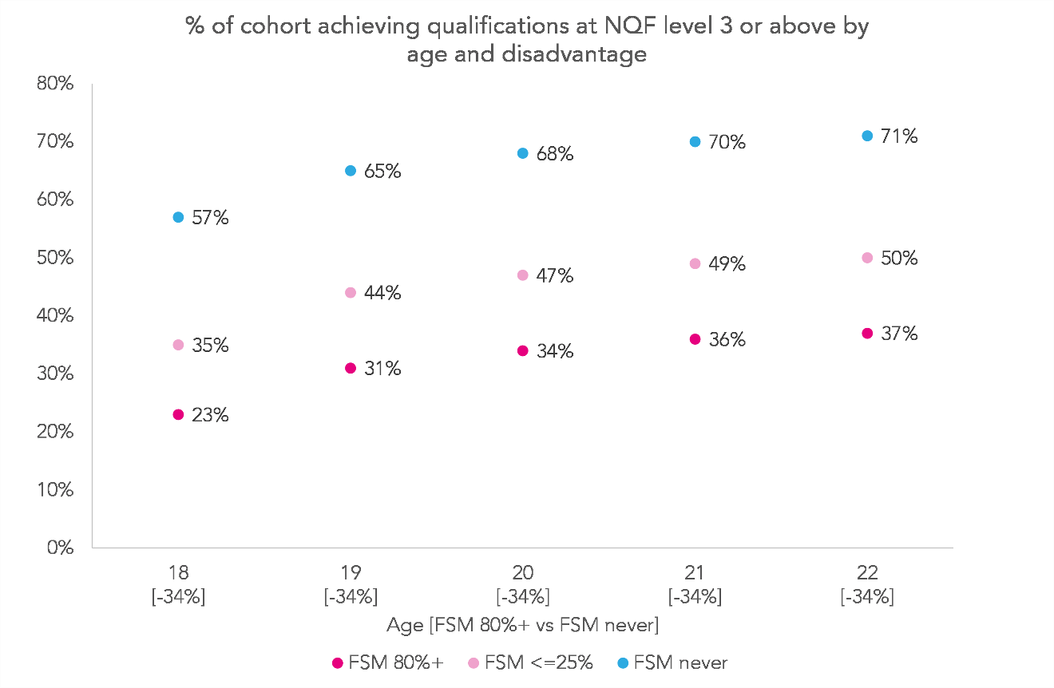
Figure 5: A chart showing the proportion of the 2013 Key Stage 4 cohort who achieved qualifications at NQF level 3 or above by different ages. Results are shown for those who were eligible for free school meals (FSM) for at least 80% of school terms, those who were eligible for 25% of terms or less, and for those who were never eligible. NQF level 3 is the equivalent of two A-levels.
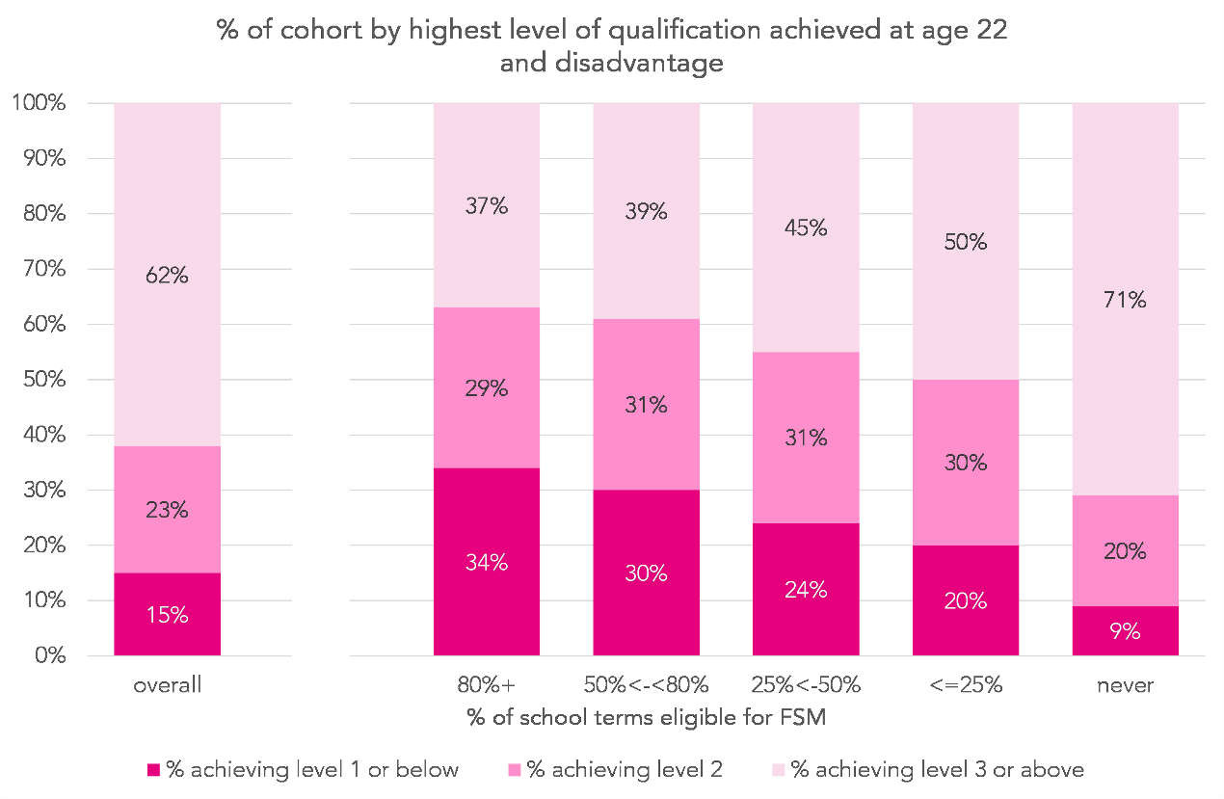
Figure 6: Chart showing the proportion of the 2013 Key Stage 4 cohort who achieved qualifications at NQF levels 1, 2 and 3 by the age of 22. The results are split by disadvantage. NQF level 1 is equivalent to achieving 5 GCSEs at grade 9-1 (A*-G), level 2 to 5 GCSEs at grade 9-4 (A*-C), and level 3 to two A-levels.
Although the proportion of those who were long-term disadvantaged achieving such qualifications increased (from 23% by age 18 to 37% by age 22) the gap between them and those who had never been eligible for FSM remained roughly the same.

Enrolment at a higher education institution at the age of 21
Perhaps unsurprisingly given the relationship between disadvantage and qualification rates, the percentage of individuals enrolled on a degree-level course at a higher education institution at the age of 21 decreased with increasing disadvantage, as shown in Figure 7.
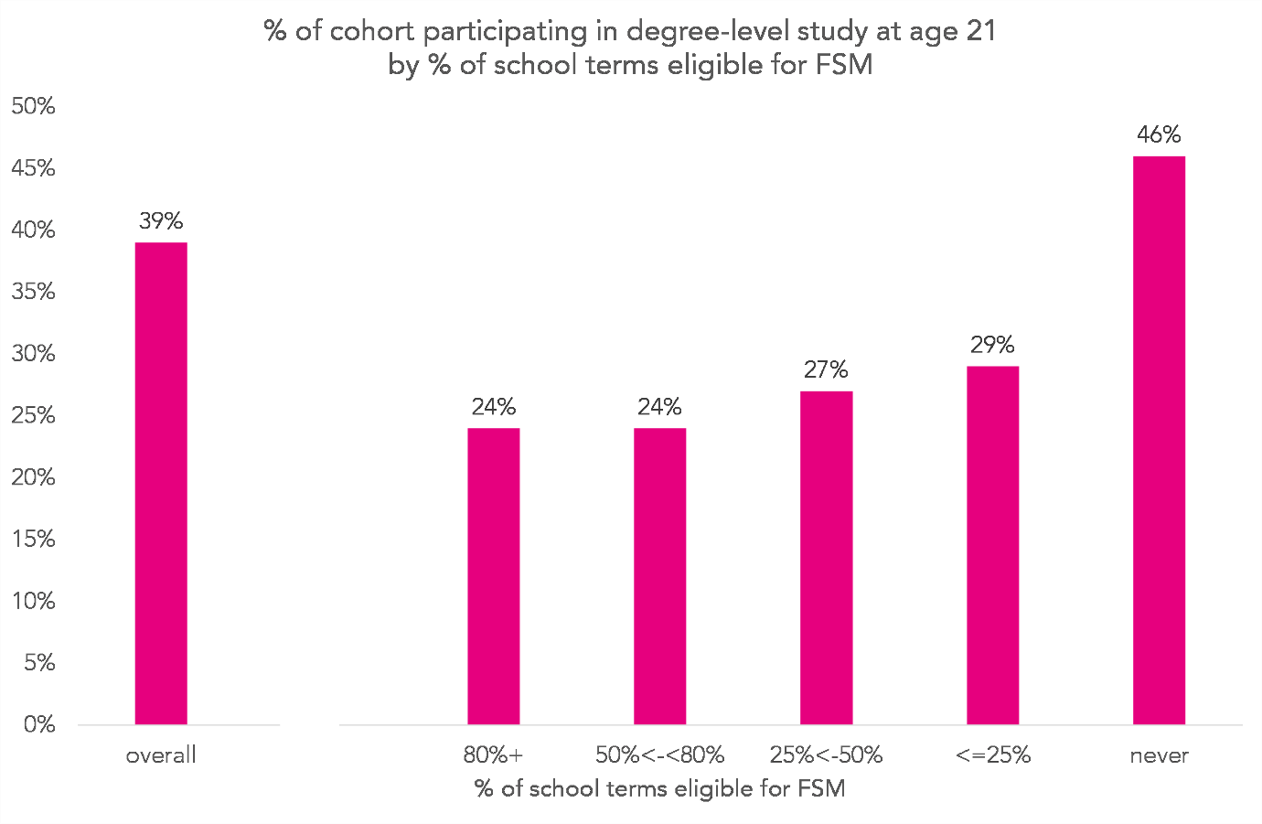
Figure 7: Chart showing the proportion of the 2013 Key Stage 4 cohort who were participating in degree-level study at age 21 by disadvantage. Degree-level study is defined as being enrolled on a qualification at NQF level 6 in a higher education institution.
Long-term disadvantaged pupils were around half as likely to be undertaking degree-level study as those who had never been eligible for FSM (24% vs 46%).

3.4. Outcomes and attainment by ethnicity

The likelihood of being in a sustained positive destination at age 22
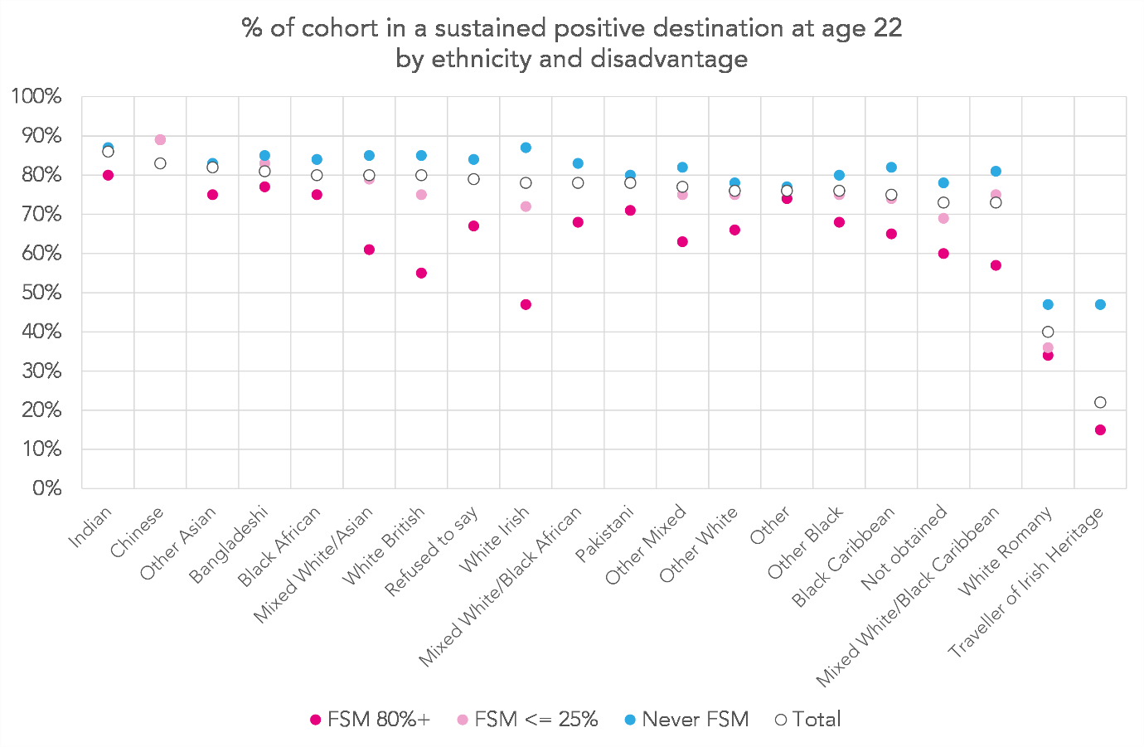
Figure 8: Chart showing the proportion of the 2013 Key Stage 4 cohort who were observed in a positive destination at age 22 by ethnicity and shown separately for the group total, those who were eligible for free school meals (FSM) for at least 80% of school terms, those who were eligible for 25% of terms or less, and those who were never eligible. A positive destination is defined as being either in employment or enrolled at an education institution for at least 180 days.
Figure 8 shows the proportion of individuals in the 2013 cohort observed in a sustained positive destination at age 22 by ethnicity and disadvantage. We see that overall, those from an Indian or Chinese background were the most likely to be observed in a positive destination, while those from White Romany or Irish Traveller backgrounds were the least likely.
The relationship between disadvantage and outcomes varies by ethnicity. We see virtually no impact of disadvantage on the likelihood of going on to a positive destination for those from Chinese backgrounds, and only a small impact for those from Indian, Other Asian, Bangladeshi, Black African and Pakistani backgrounds. There also appears to be little impact for those from a White Romany background – very few were observed in a positive destination regardless of FSM eligibility.
In contrast, there is a big impact for those from White Irish, White British and Irish Traveller backgrounds and, to a lesser extent, those from Mixed White/Asian and Mixed White/Black Caribbean backgrounds.

The likelihood of achieving qualifications at Level 3 or above by 22
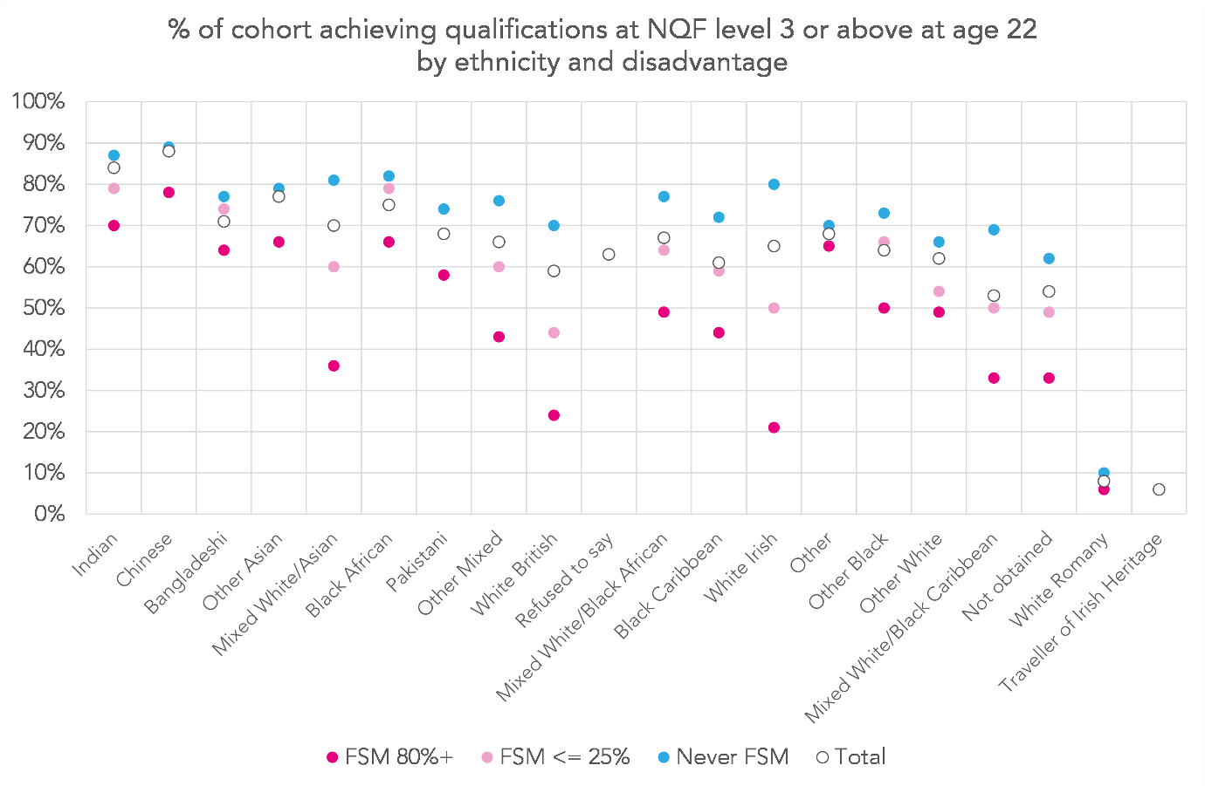
Figure 9: A chart showing the proportion of the 2013 Key Stage 4 cohort who achieved qualifications at NQF level 3 or above by age 22. Results are split by ethnicity and shown separately for the group total, those who were eligible for free school meals (FSM) for at least 80% of school terms, those who were eligible for 25% of terms or less, and those who were never eligible. NQF level 3 is the equivalent of two A-levels. Values which relate to small numbers of individuals are suppressed.
In Figure 9, we see a similar pattern for level 3 qualification rates. There was little difference between the most and least disadvantaged individuals from Chinese, Indian, Black African, Pakistani and White Romany backgrounds, while there were big differences for those from Mixed White/Asian, White Irish, White British and Mixed White/Black Caribbean backgrounds.
There were bigger differences in qualification rates than likelihood of going on to a positive destination for those from Mixed White/Black African and Black Caribbean backgrounds.
Figure 10 shows an almost identical pattern for the likelihood of participating in degree-level study at age 21.

Participating in degree-level study at age 21
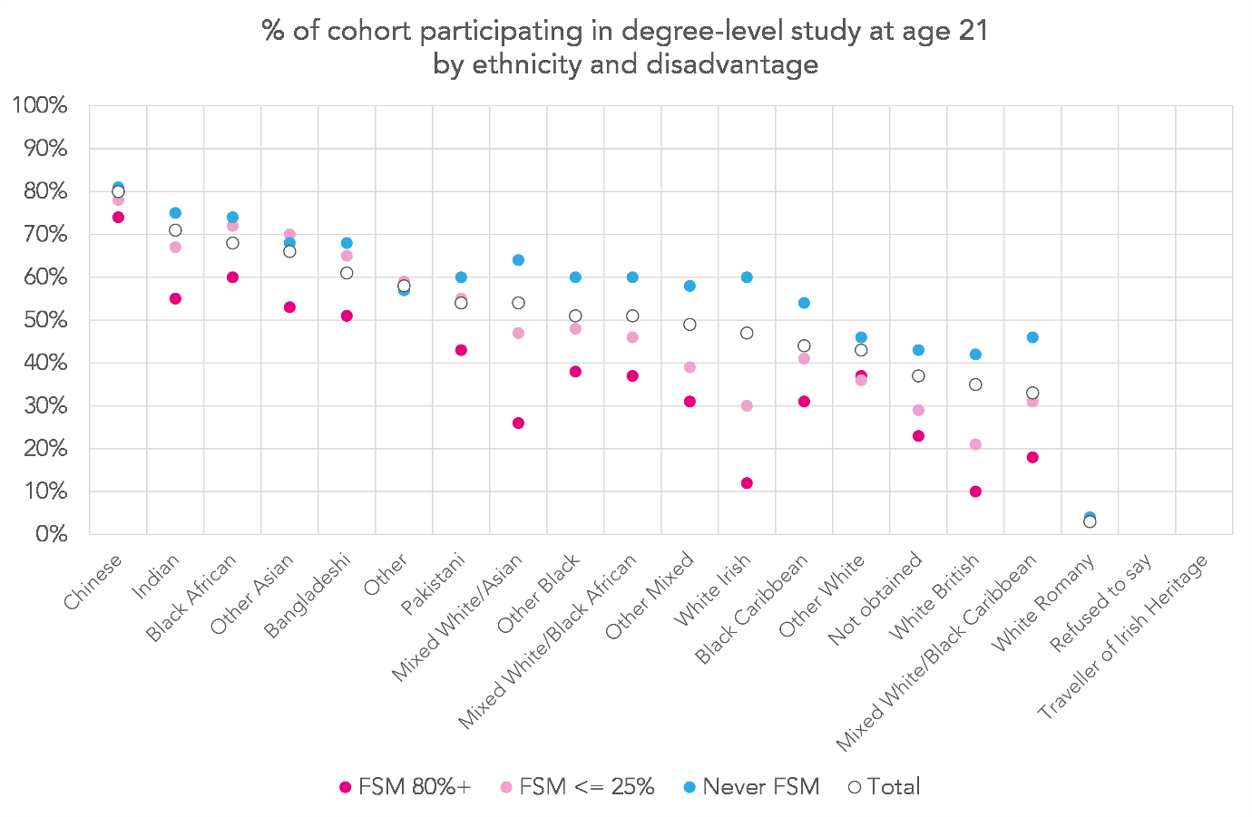
Figure 10: Chart showing the proportion of the 2013 Key Stage 4 cohort who were participating in degree-level study at age 21. Results are split by ethnicity and shown separately for the group total, those who were eligible for free school meals (FSM) for at least 80% of school terms, those who were eligible for 25% of terms or less, and those who were never eligible. Degree-level study is defined as being enrolled on a qualification at NQF level 6 in a higher education institution.

3.5. Outcomes and attainment by region

The likelihood of being in a sustained positive destination at age 22
To finish, we investigate how outcomes vary by region and disadvantage. The proportions of individuals observed in a sustained positive destination at age 22 are shown in Figure 11.
Overall there is less variation in the likelihood of being observed in a positive destination between individuals from different regions than between those from different ethnic backgrounds. In the region with the lowest likelihood, the North East, 77% of individuals were in a positive destination, and in the region with the highest, the South West, this figure stood at 81% - a range of 4pp. The range between the ethnicities with the highest and lowest likelihoods was 64pp (or 13pp, excluding Travellers of Irish heritage and those from a Romany background – both negative outliers).
Within regions, there is considerable variation by disadvantage, mirroring the national picture. In almost every region, those who were long-term disadvantaged were around 30% less likely to be observed in a sustained positive destination than those who had never been eligible for FSM. The exception is London, where they were 16% less likely.
Those who were long-term disadvantaged were most likely to go on to a sustained positive destination of they lived in London (69%) and least likely if they lived in the North East (54%).
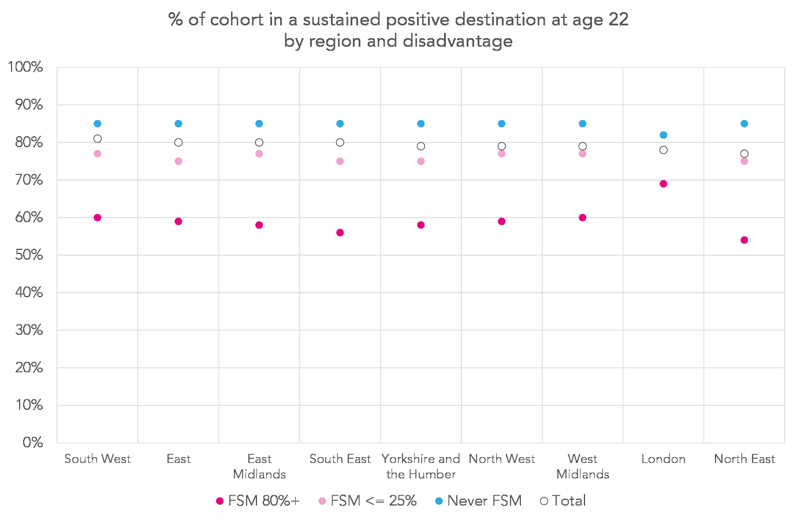
Figure 11: Chart showing the proportion of the 2013 Key Stage 4 cohort who were observed in a positive destination at age 22 by region and shown separately for the group total, those who were eligible for free school meals (FSM) for at least 80% of school terms, those who were eligible for 25% of terms or less, and those who were never eligible. A positive destination is defined as being either in employment or enrolled at an education institution for at least 180 days. Region is based on school attended at age 16.

The likelihood of achieving qualifications at Level 3 or above by 22
Figure 12 shows the proportion of individuals who achieve qualifications at NQF Level 3 (the equivalent of at least 2 A-Levels) by the age of 22 by region and disadvantage.
Again, there isn’t too much variation between regions, overall, though qualification rates for those in London were slightly higher than in the rest of the country (67% in London vs around 60% elsewhere).
Differences within regions broadly mirror the national picture, with those who were long-term disadvantaged being between 50 and 65% less likely to achieve Level 3 qualifications than those who had never been eligible for FSM. In London, they were around 30% less likely.
Qualification rates for those who were long-term disadvantaged were substantially better in London than elsewhere – 54% achieved Level 3 qualifications compared with 36% in the West Midlands, the second best region on this measure. Rates were lowest in the South West (24%), South East (25%) and East Midlands (26%).

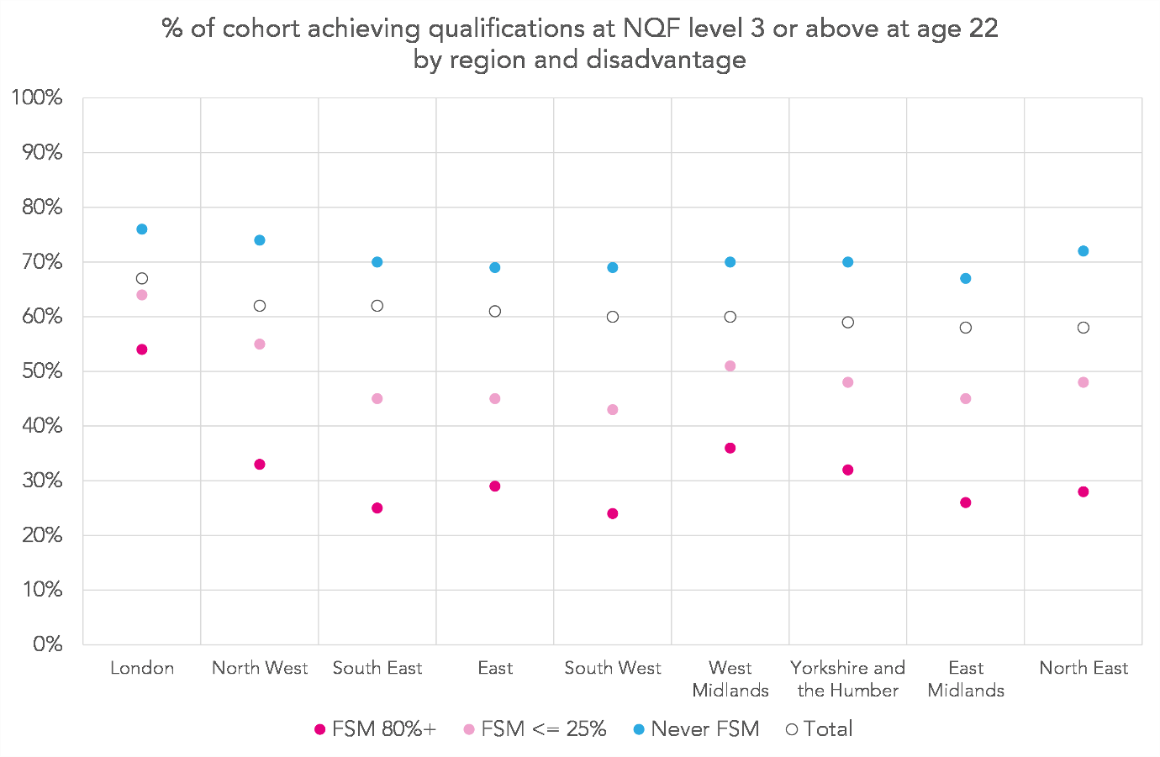
Figure 12: A chart showing the proportion of the 2013 Key Stage 4 cohort who achieved qualifications at NQF level 3 or above by age 22. Results are split by ethnicity and shown separately for the group total, those who were eligible for free school meals (FSM) for at least 80% of school terms, those who were eligible for 25% of terms or less, and those who were never eligible. NQF level 3 is the equivalent of two A-levels. Region is based on school attended at age 16.

Participating in degree-level study at age 21
There are similar patterns in rates of degree-level study, though London is even more of an outlier on this measure, as shown in Figure 13.
In London, 44% of those who were long-term disadvantaged were observed undertaking degree-level study at age 21 – a similar proportion of those who had never been eligible for FSM in the rest of the country (which ranges from 41% in the South West to 47% in the North West).
In general, apart from in London, those who were long-term disadvantaged were between 60 and 70% less likely to be participating in degree-level study than those who had never been eligible for FSM. In London, they were around 25% less likely.
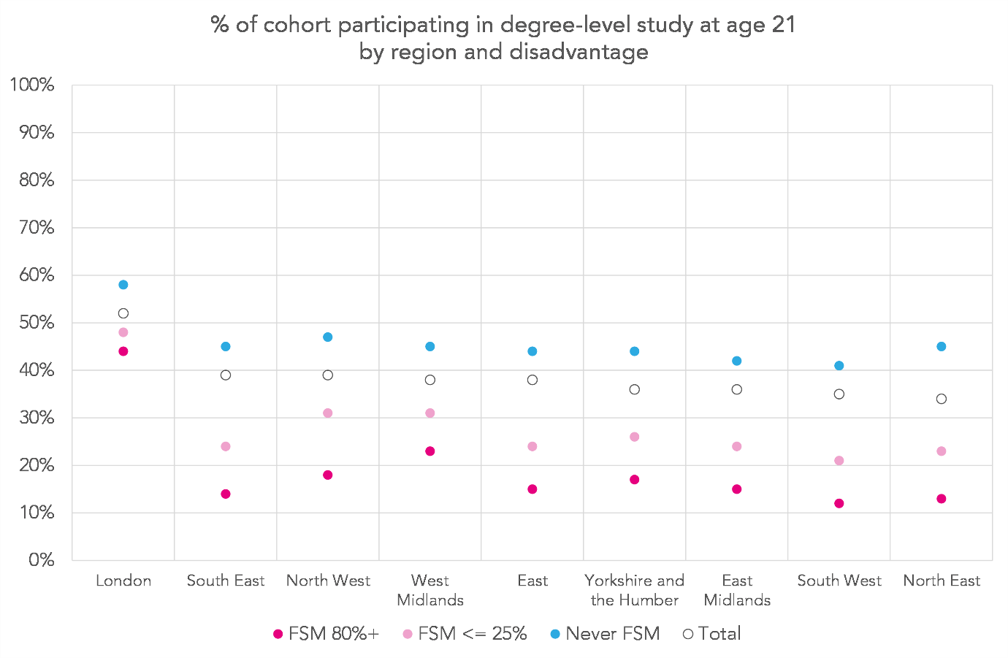
Figure 13: Chart showing the proportion of the 2013 Key Stage 4 cohort who were participating in degree-level study at age 21. Results are split by region and shown separately for the group total, those who were eligible for free school meals (FSM) for at least 80% of school terms, those who were eligible for 25% of terms or less, and those who were never eligible. Degree-level study is defined as being enrolled on a qualification at NQF level 6 in a higher education institution. Region is based on school attended at age 16.

3.6. Outcomes and attainment for long-term disadvantaged individuals by region and ethnicity

Ethnic composition of the long-term disadvantaged group by region
Some of the variation in outcomes by region can be explained by different ethnic compositions of the underlying populations. To explore this, we divide individuals into two groups based on their ethnic backgrounds (based on previous work which largely mirrors results in section 3.4.):
- Where disadvantage has a high impact on outcomes – those from White British, White Irish, Irish Traveller, Roma, Black Caribbean, and Mixed White and Black Caribbean backgrounds, as well as those whose ethnic background is unknown.
- Where disadvantage has a low impact on outcomes – those from any other ethnic background.
Table 10 (overleaf) shows the proportion of the cohort in each region by the two ethnicity groupings above.
There is considerable variation between regions. In the North East 94% of the cohort belong to a high-impact ethnic group, compared with 79% in the West Midlands. London is a particular outlier, with a greater of the cohort belonging to a low-impact ethnic group (54%) than high-impact.
There is a similar pattern among long-term disadvantaged individuals. The North East has the greatest proportion of individuals belonging to a high-impact ethnic group (94%) and London the lowest (33%). London is, again, an outlier.
Table 10: A summary the 2013 Key Stage 4 cohort by high/low impact ethnicity grouping and region, shown separately for the cohort overall and for those who were eligible for free school meals (FSM) for at least 80% of their school careers. Region is defined by the school that individuals attended at age 16. The “high impact” ethnicity grouping includes those from White British, White Irish, Irish Traveller, Roma, Black Caribbean, and Mixed White and Black Caribbean backgrounds, as well as those whose ethnic background is unknown. The “low impact” grouping contains individuals from all other ethnic backgrounds.
 | FSM 80%+ |  |  |  | Overall
Region | Cohort (000s) | % high impact | % low impact |  | Cohort (000s) | % high impact | % low impact
Overall | 49.2 | 67% | 33% |  | 599.3 | 80% | 20%
North East | 3.7 | 94% | 6% |  | 29.8 | 94% | 6%
South West | 2.5 | 89% | 11% |  | 58.9 | 92% | 8%
East | 3.0 | 82% | 18% |  | 68.0 | 85% | 15%
South East | 3.7 | 82% | 18% |  | 94.4 | 85% | 15%
North West | 9.1 | 80% | 20% |  | 83.8 | 87% | 13%
East Midlands | 3.0 | 79% | 21% |  | 52.4 | 85% | 15%
Yorkshire and the Humber | 5.3 | 73% | 27% |  | 61.0 | 84% | 16%
West Midlands | 6.6 | 63% | 37% |  | 67.9 | 79% | 21%
London | 12.4 | 33% | 67% |  | 83.2 | 46% | 54%

Outcomes for long-term disadvantaged individuals by region and ethnic group
Figure 14 shows key outcomes for long-term disadvantaged individuals broken down by region and high/low-impact ethnicity grouping. Overall, when we look at outcomes separately for those from high- and low-impact ethnic backgrounds, the regions are much more similar than when we look at outcomes for the long-term disadvantaged group as a whole.
Figure 14b) shows that long-term disadvantaged individuals from London had the highest qualification rates, being around 50% more likely to achieve qualifications at Level 3 or above compared with the second highest region (54% in London vs 36% in the West Midlands). Those from high-impact ethnic backgrounds living in London had better qualification rates than those living elsewhere, but they were only 16% more likely to achieve level 3 qualifications than those in second highest region (32% in London vs 28% in the North West). Similarly, those from low-impact ethnic backgrounds living in London had better qualification rates than those living elsewhere, but only 14% better than the second highest region.
We see a similar pattern for higher education participation in Figure 14c). However, those from high-impact ethnic backgrounds living in London were still around 50% more likely to be studying for a degree than in the second highest region (19% in London vs 12% in the North West). The corresponding figure for those from low-impact backgrounds was around 25% (56% in London vs 44% in the East) and for long-term disadvantaged individuals overall was 88% (44% in London vs 23% in the West Midlands).

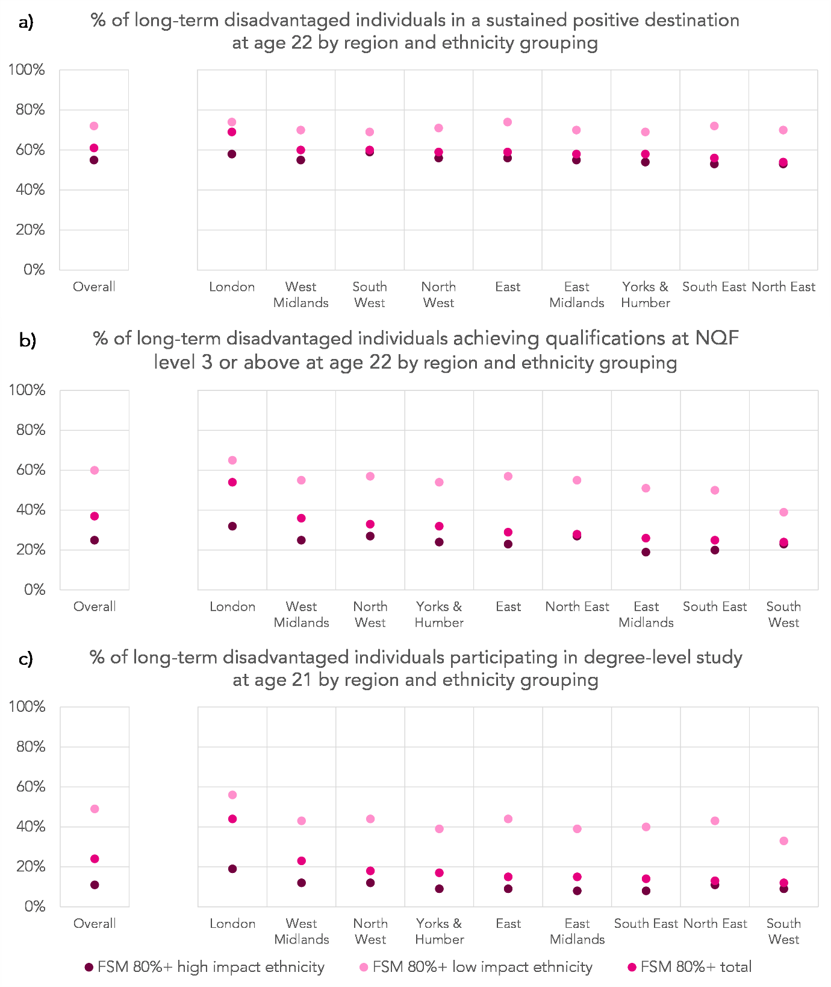
Figure 14: Charts showing, for individuals in the 2013 Key Stage 4 cohort who spent at least 80% of their school terms eligible for free school meals (FSM) a) the proportion observed in a positive destination at age 22, b) who achieved qualifications at NQF level 3 or above by age 22, and c) the proportion participating in degree-level study at age 21. Results are split by region and shown separately for the group total, and for those from a high- and low-impact ethnic group.
A positive destination is defined as being either in employment or enrolled at an education institution for at least 180 days. NQF level 3 is the equivalent of two A-levels. Degree-level study is defined as being enrolled on a qualification at NQF level 6 in a higher education institution. The “high impact” ethnicity grouping includes those from White British, White Irish, Irish Traveller, Roma, Black Caribbean, and Mixed White and Black Caribbean backgrounds, as well as those whose ethnic background is unknown. The “low impact” grouping contains individuals from all other ethnic backgrounds. Region is based on school attended at age 16.
On the broader measure of outcomes – the proportion of individuals observed in a sustained positive destination at age 22 – we see the biggest shift. For the long-term disadvantaged group as a whole, there is a difference of around 14pp between the regions with the best and worst outcomes (69% in London vs 54% in the North East). When the group is divided into low- and high- impact ethnic backgrounds, the difference is around 5-6% (for low-impact backgrounds, 74% in London vs 69% in the South West, for high-impact backgrounds, 59% in the South West vs 53% in the South East).

4. Conclusions
Disadvantage is associated with negative long-term outcomes. Those who spent time eligible for FSM whilst at school were less likely than their peers to be observed in education or employment at age 22, and were more likely to be receiving workless benefits. Lower qualification rates at the end of compulsory schooling persisted into early adulthood, with lower rates of degree-level study also observed. Crucially, outcomes worsened with severity of disadvantage – those who spent the longest proportion of their school careers eligible for FSM had the worst outcomes.
The relationship between disadvantage and outcomes varied by ethnicity. For those from some ethnic backgrounds, outcomes were similar regardless of time spent eligible for FSM at school, for example, those from Chinese, Indian, Bangladeshi, Pakistani, Other Asian, and Black African backgrounds. For others, time eligible for FSM had a big impact on outcomes, particularly those from White Irish, White British and Irish Traveller backgrounds.
There was little variation by region in the relationship between disadvantage and outcomes, apart from in London where outcomes among the most disadvantaged individuals tended to be better than elsewhere. Much of this can be explained by the different ethnic composition of the long-term disadvantaged group in London compared with other regions.

Treadaway, M. (2014), “Pupil Premium and the invisible group”. FFT Research Paper No 5, June 2014. [PDF]
Long-term disadvantage, part three: Ethnicity, EAL and long-term disadvantage – Mike Treadaway
Education Inequalities – IFS review
Education, social mobility and outcomes for students receiving free school meals in England: initial findings on earnings outcomes by demographic and regional factors – ONS article
Why free school meal recipients earn less than their peers – ONS article
National Qualifications Framework (NQF) levels: Level 1 is equivalent to 5 or more GCSEs at grades 9-1 (A*-G), Level 2 is equivalent to 5 or more GCSEs at grades 9-4 (A*-C); Level 3 is equivalent to 2 or more A levels; Level 6 is equivalent to a first degree.
Jobseekers Allowance (JSA), Jobseekers Training Allowance (JTA), Employment and Support Allowance (ESA), Incapacity Benefit (IB), Income Support (IS), Passported IB (PIB), Severe Disablement Allowance (SDA), Pension Credit (PC), State (Retirement) Pension (RP), Carers Allowance (Invalid Carers Allowance – ICA), Attendance Allowance (AA), Universal Credit – Searching for Work (UAA), Universal Credit – No Work requirements (UBC), Universal Credit – Preparing for work (UCE), Universal Credit – Planning for work (UDF)
The impact of being long-term disadvantaged at KS2 and KS4 - FFT Education Datalab blog

