Progress 5: A performance measure for Alternative Provision and Special Schools

Alternative Provision (AP) and Special schools are both served poorly by current Key Stage 4 performance indicators. Firstly, and following the Wolf Review of 2013, not all qualifications approved for use by 16 year olds under Section 96 of the Education and Skills Act 2000 are counted in the measures in School Performance Tables. This includes a raft of qualifications, including Functional Skills, commonly taken in AP and Special schools. Secondly, the principal performance measure, Progress 8, is a measure of attainment conditional on prior (Key Stage 2) attainment for pupils attending mainstream schools only. The attainment of pupils in AP and Special schools is compared against this. Yet many of these pupils would have moved to either the AP or Special sector having struggled in the mainstream sector.
School-level data for AP schools is not even published. The Department for Education (DfE) currently produces Key Stage 4 statistics for pupils in alternative provision aggregated at local authority level. However, this data includes not only pupils who attend AP schools but also pupils who are in local authority funded alternative provision. This latter group are pupils for whom local authorities are paying fees to be educated outside the state-funded school sector, including pupils placed in independent special educational needs (SEN) schools.
In this report, we follow-up some previous analysis conducted pre-pandemic to calculate some suitable Key Stage 4 performance measures for 2022 for AP and Special schools that are based on all approved qualifications.
This work contains statistical data from ONS which is Crown Copyright. The use of the ONS statistical data in this work does not imply the endorsement of the ONS in relation to the interpretation or analysis of the statistical data. This work uses research datasets which may not exactly reproduce National Statistics aggregates. The work was carried out in the Secure Research Service, part of the Office for National Statistics.

Data
We use pupil-level and exam-level Key Stage 4 data for 2022 from the National Pupil Database.
Our first stage is to calculate points scores equivalent to GCSE grades for qualifications that are approved for use by 16 year olds but which are not counted in Performance Tables. We do this in line with the principles of DfE guidance on performance points for different qualifications.
For each qualification, we find the number of scoring grades at each Level, for example Level 1 Introductory BTEC certificates have three grades (D/M/P), all at Level 1. We then find the modal (most frequently occurring) set of non-zero points that are assigned to qualifications with the same number of grades (regardless of what those grades are called) at the same level, once qualification size (full or short course, for example) is accounted for. These scores, multiplied by qualification size, are then used in place of zero point-score values.
Unfortunately, this does leave some gaps where no non-zero value has been awarded for any “equivalent” grade. In these cases we fill in gaps by observing some common patterns such as the points award for consecutive grades most frequently follow a linear sequence (where each value differs from the previous one by a constant) and where there are many grades, this is exclusively double and triple awards, where the points can be determined by summing the equivalent points for single grades.
Finally, no entry-level qualifications are included in Performance Tables at all so it is not possible to assign or impute scores in the same manner. We instead assign points to all grades based on the sub-level, dividing the range between zero and one evenly: qualifications achieved at Entry Level 3, 2 and 1 achieve 0.75, 0.5 and 0.25 points respectively.
A list of common qualifications and their points scores can be found in ANNEX A.
We produce statistics for two groups of schools:
- AP schools
  - Pupil referral units
  - Alternative provision academies
  - Alternative provision free schools
- Special schools
  - Community special
  - Foundation special
  - Non-maintained special
  - Special academies
  - Special free schools
We do not include pupils in local authority funded AP outside the state-funded sector nor hospital schools.

Current Performance Measures
Headline measures of Key Stage 4 performance currently published in School Performance Tables are:
- Attainment 8
- Progress 8
- Percentage of pupils achieving grades 9-5 in both GCSE English and GCSE Maths (often referred to as “the basics”
- Percentage of pupils entered for the English Baccalaureate (EBacc)
- Average point score (APS) in EBacc subjects
Summary measures for AP and special schools compared to mainstream schools are shown in Table 1. We also show the mean number of qualifications counted in Performance Tables entered by pupils and the percentage entered for at least 1.
Table 1: Key Stage 4 performance (published measures) by school type, 2022
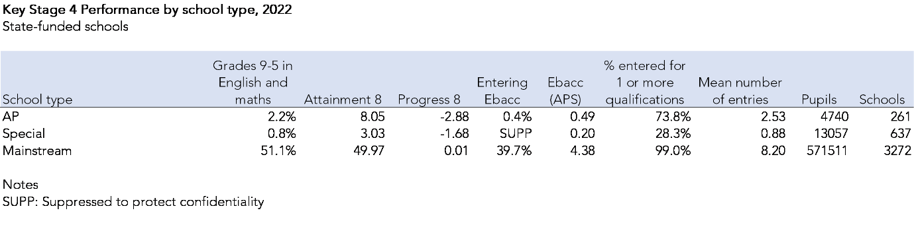
Very few pupils who attend AP schools achieve grades 9-5 in English and maths, and hardly any enter the EBacc. Progress 8 scores are well below average. A simplistic reading of the Progress 8 score for AP schools suggests pupils achieve 3 grades lower in each qualification than pupils with similar Key Stage 2 attainment in mainstream schools. However, pupils in AP and special schools tend to enter far fewer qualifications so this low Progress 8 score tends to arise as a result of this.

Proposed Performance Measures
We calculate a new set of performance measures based on all approved qualifications, not just those included in Performance Tables. These are:
- Percentage of pupils achieving the basics (passes in literacy and numeracy)
  - At Level 2 or above
  - At Level 1 or above
  - At Entry level or above
- Attainment 5 (A5)
  - English/ literacy
  - Maths/ numeracy
  - Any other 3 subjects
  - Total A5 score
- Entries
  - % of pupils entering 1 or more qualifications
  - % of pupils entering 1 or more qualifications in each of the 3 A5 buckets
  - % of pupils entered for 5 qualifications in A5
The basics measures cover attainment in English/ literacy and maths/ numeracy. GCSEs, functional skills and any other approved qualifications in literacy/ numeracy are included. If a pupil has entered GCSE English language and GCSE English literature, the best grade is counted. We summarise whether pupils have a pass in both subjects at level 2 (grades 9-4 at GCSE, a level 2 pass in Functional Skills or equivalent), at level 1 (grades 9-1 at GCSE, a level 1 pass in Functional Skills or equivalent), and at entry level (any pass in an approved qualification in both literacy and numeracy).
Attainment 5 is made up of 3 “buckets”
- English/ literacy (double weighted)
- Maths/ numeracy (double weighted)
- Any other 3 subjects
Summary measures for pupils in AP and special schools are presented in Table 2.
Table 2: Key Stage 4 performance (calculated measures) by school type, 2022

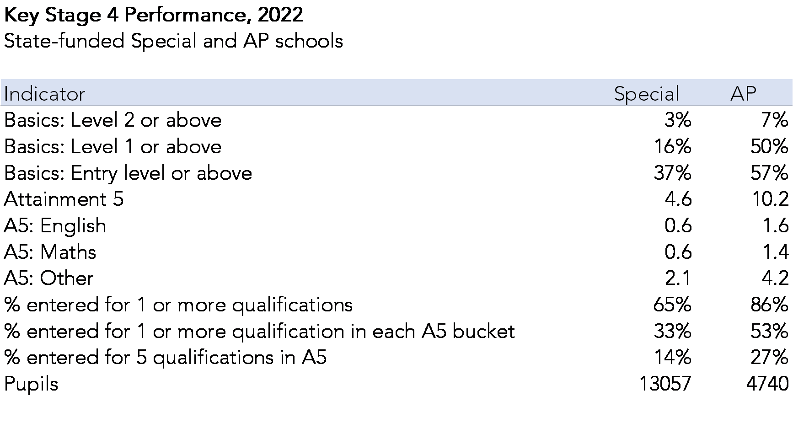
50% of pupils in AP schools and 16% of pupils in special schools achieved the Basics at Level 1 in 2022. The average Attainment 5 score was 10.2 in AP schools and 4.6 in special schools. 86% of pupils in AP schools and 65% of pupils in special schools were entered for at least one qualification. This latter pair of figures can be compared with those shown in Table 1, which was based solely on those qualifications counted in Performance Tables. Just 28% of pupils in special schools were observed to enter 1 qualification according to Performance Tables. This shows the importance of including all qualifications in measures for special schools.
That said, it is likely to be the case that a number of previously popular qualifications that were typically used in AP and special schools have been withdrawn entirely since changes to Performance Tables were introduced. In other words, the pool of suitable qualifications may well be smaller now than in the past. This would be worthy of further investigation.

Prior attainment
Most pupils in the 2022 Key Stage 4 cohort would have been assessed at the end of Key Stage 2 in 2017.
The DfE Progress 8 calculation measures attainment (the Attainment 8 measure) conditional on average Key Stage 2 attainment. In this case, the average scaled score in Key Stage 2 reading and maths is used.
In the chart below, we show the distribution of KS2 average scaled score for pupils in AP schools compared to mainstream schools. The prior attainment groups we use (shown on the horizontal axis) are those used in the Progress 8 calculation.
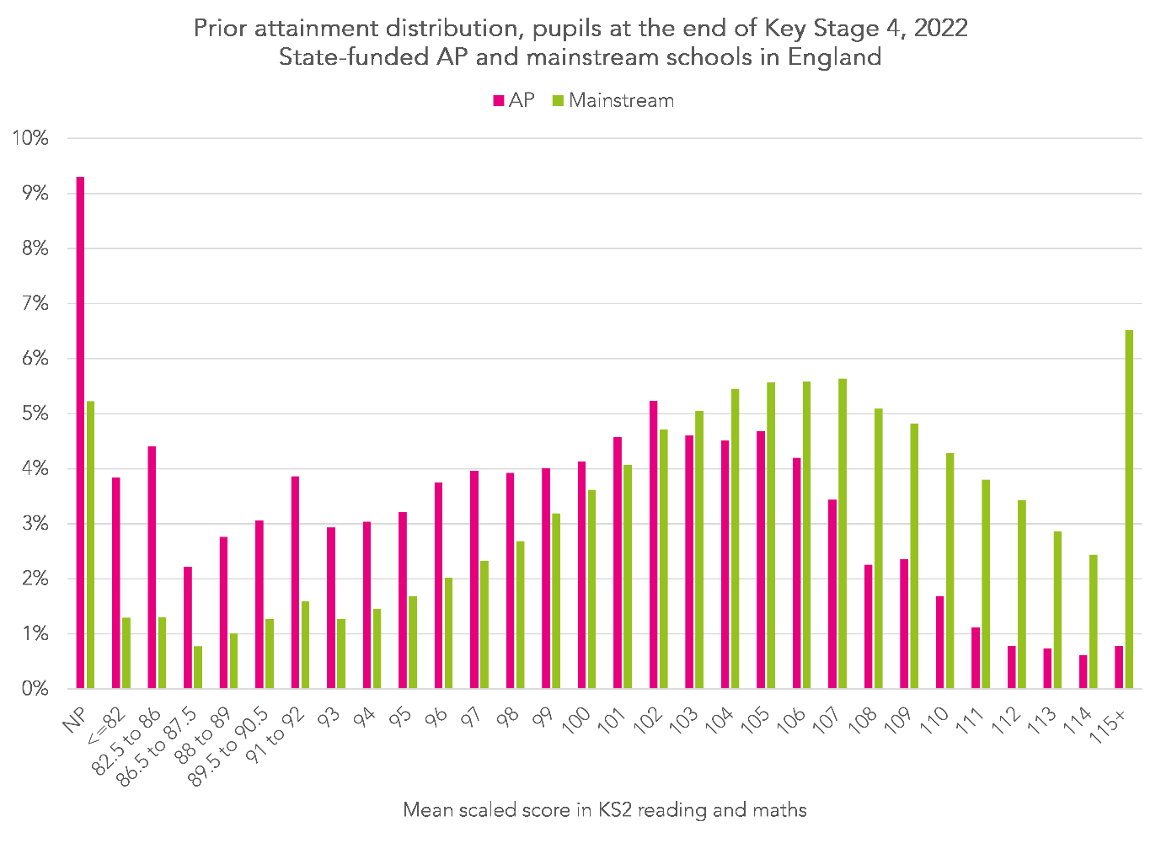
Pupils in AP schools tend to be lower attaining than those in mainstream. 46% of pupils in AP schools achieved a score of 100 (the expected standard at KS2) or above compared to 73% of pupils in mainstream schools. In other words, pupils in AP schools weren’t all low attaining at the end of KS2 although some were. 9% of pupils in AP schools were not assessed at KS2. This may indicate being overseas (or in home education) at the time.
We do not show a distribution for special schools since 61% of pupils would be in the lowest group. 7% of pupils in special schools achieved an average score of 100 or above in KS2 reading and maths tests.

Calculating Progress 5
Progress 5 (P5) follows similar principles to Progress 8. It is a value-added measure that compares the attainment (Attainment 5) of pupils to that of other pupils with similar prior attainment.
The principal differences between A5/P5 and A8/P8 are:
- A5 and P5 are based on attainment in 5 subjects
- All qualifications are included, not just those counted in Performance Tables
- There is no requirement to enter EBacc subjects
- P5 is calculated separately for AP schools and special schools
- P5 uses a different set of prior attainment groups (but still based on KS2 reading and maths)
The following charts show the prior attainment groups (PAGs) and corresponding mean 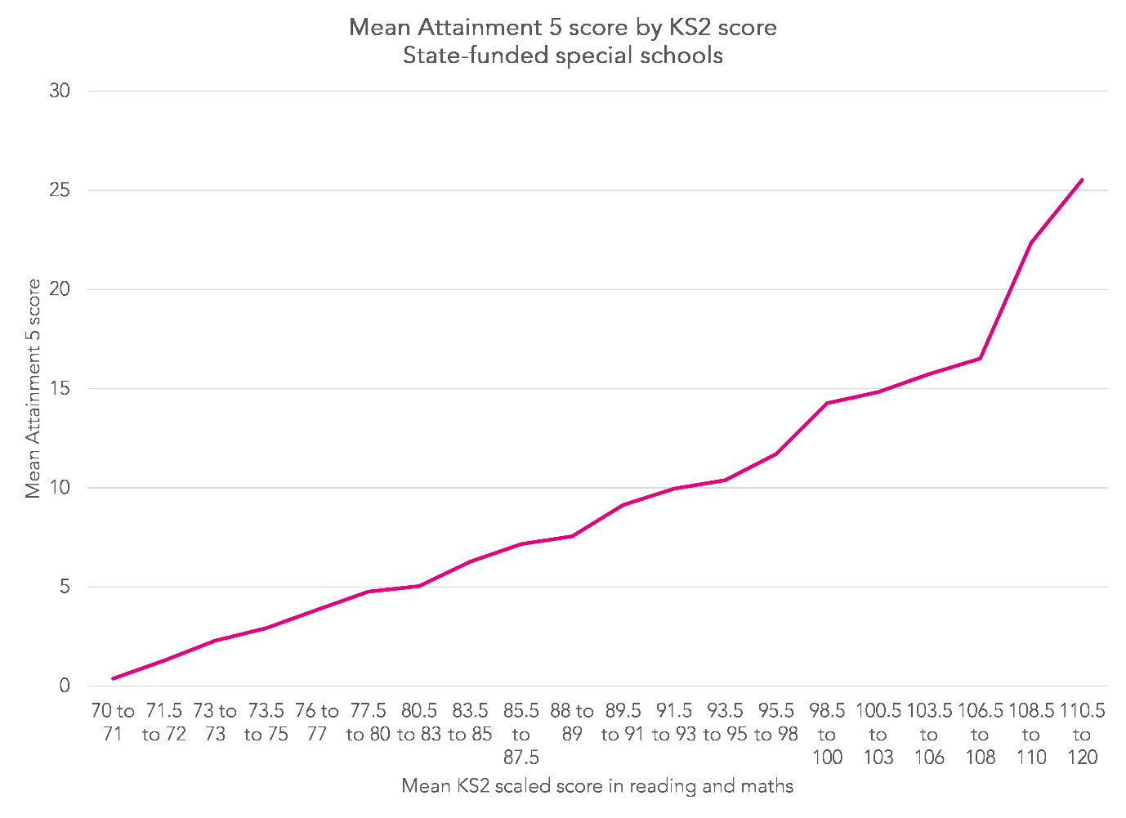
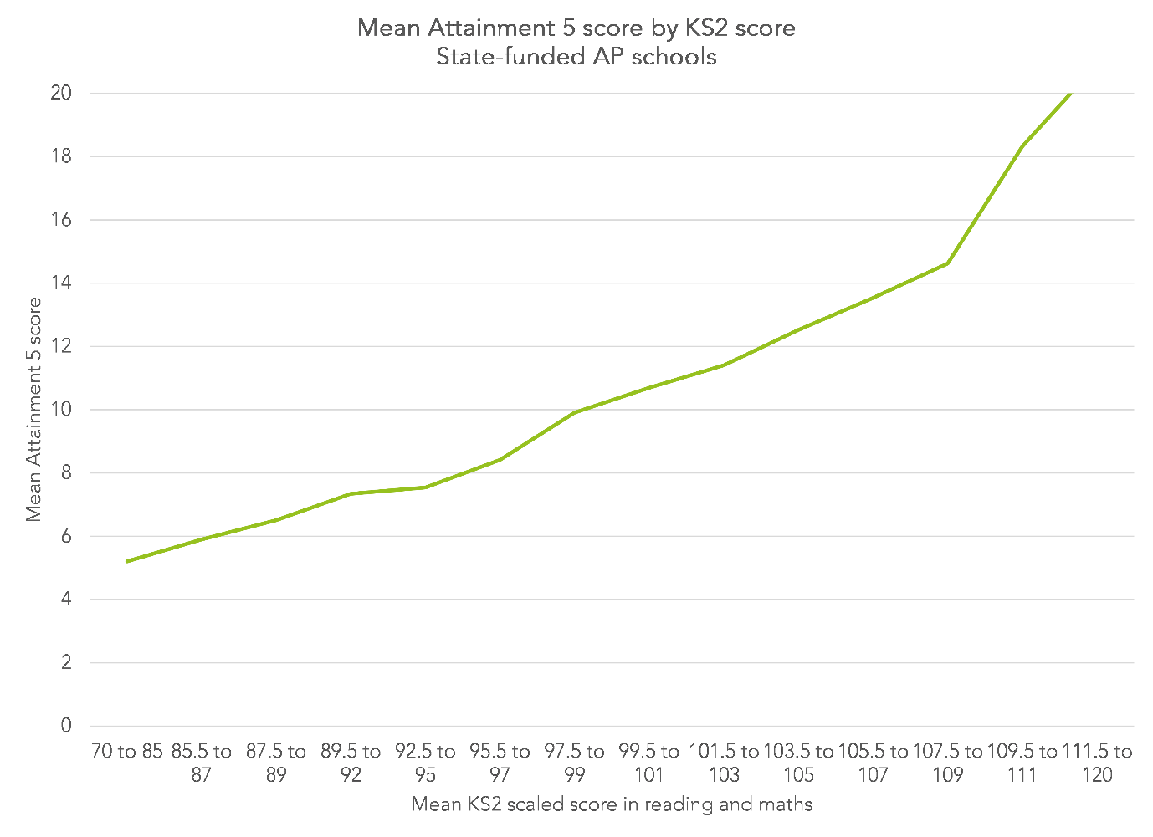
The line in each chart defines the expected Attainment 5 score for a given pupil with a given level of KS2 attainment in a) special schools and b) AP schools.
For example, the expected Attainment 5 score of a pupil with a KS2 scaled score of 89 attending a special school would be 7.55. If their actual Attainment 5 score was 10, their personal Progress 5 score would be (10 – 7.55)/7 = 0.35. This suggests their attainment was 0.35 GCSE grades higher in each of the 7 “slots” of Progress 5 (there are 5 subjects but English and maths are double weighted, hence 7 slots) than that of pupils with similar prior attainment in special schools.
Similarly, the expected Attainment 5 score of a pupil with a KS2 scaled score of 89 attending an AP school would be 6.51. If their actual Attainment 5 score was 10, their personal Progress 5 score would be (10 – 6.51)/7 = 0.5. This suggests their attainment was 0.5 GCSE grades higher in each of the 7 “slots” of Progress 5 than that of pupils with similar prior attainment in AP schools.

Pupil characteristics
Summary attainment measures broken down by primary SEN type are shown in Table 3. (Almost) all pupils in special schools have Education, Health and Care (EHC) plans whereas the AP sector includes pupils with SEN met by SEN Support as well as pupils without SEN and those with EHC plans.
Table 3: Key Stage 4 Performance by Primary SEN Type and School Type, 2022
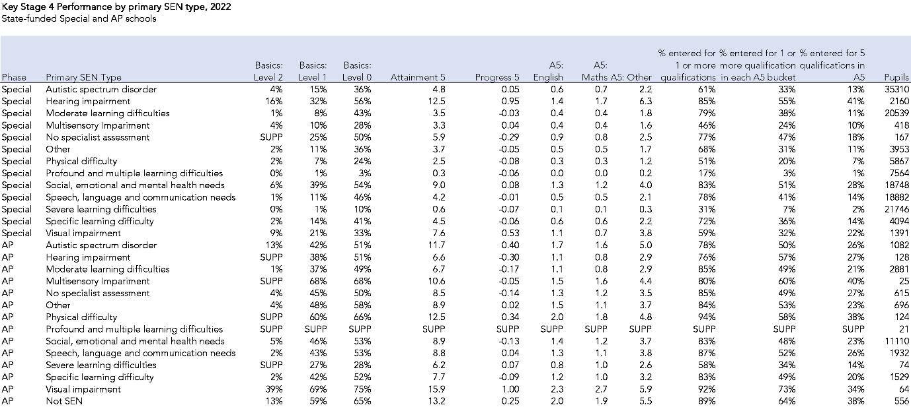
In the special sector, pupils with hearing impairment tend to be higher attaining, achieving a Progress 8 score 0.95 grades higher per subject than other pupils with similar prior attainment in the special sector.
In the AP sector, pupils with visual impairment tend to be the highest achieving, even more so than those without any identified SEN.
In both sectors, and as expected, pupils with profound and multiple learning difficulties (PMLD) or severe learning difficulties (SLD) tend to be the lowest achieving and the least likely to enter any qualifications.
Table 4 presents summary measures for pupils broken down by gender and disadvantage (measured by eligibility for free school meals in the last 6 years).
Table 4: Key Stage 4 Performance by Pupil Characteristics and School Type, 2022
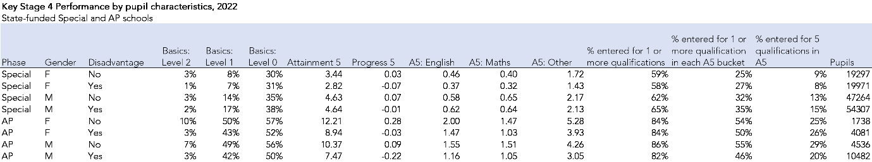
The measures in AP schools follow the pattern of mainstream schools. Girls tend to be higher attaining than boys and disadvantaged pupils tend to be lower attaining than other pupils.
However, this is not the case in special schools. Boys tend to be (slightly) higher performing and gaps in Progress scores between disadvantaged pupils and their peers are much narrower.

Which pupils should be included in performance measures for AP schools?
Up to this point, we have calculated performance measures for AP schools consistent with Key Stage 4 Performance Tables.
Allocations of pupils to schools are made largely on the basis of January School Census. At that time, 88% of pupils included in KS4 performance measures for AP schools were single-rolled, that is to say were only on the roll of the AP school (Table 5). The remainder were dual-rolled, that is they attended another setting as well as the AP school against which they were recorded in KS4 data. There was a roughly 50:50 split for whom the AP school was the main setting they attended and those for whom the AP school was a subsidiary setting.
Table 5: Enrolment status in January 2022 of pupils included in KS4 performance measures for AP schools
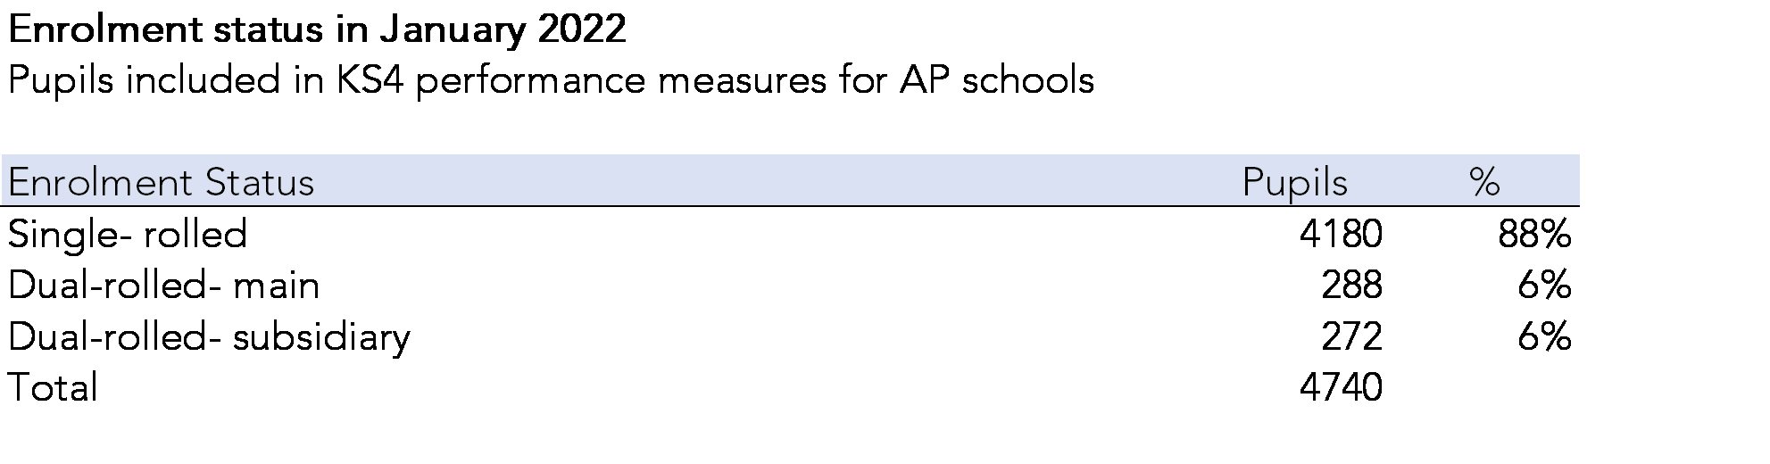
However, the total number of pupils included in performance measures (4,740) was a fraction of the total number of pupils who accessed AP schools in Year 11.
In total, we observe in School Census 10,660 enrolments of pupils of Year 11 age in School Census in the 2021/22 up to the date of the Summer Census (19th May 2022). These enrolments relate to 10,342 distinct pupils (i.e. a small number of pupils had enrolments at more than one AP school).
In Table 6, we show the end of Key Stage 4 destinations of these pupils. Destinations are based on the type of school against which pupils were recorded in end of Key Stage 4 data for 2022.
Table 6: End of Key Stage 4 destinations of 16 year old pupils who attended AP schools in 2021/22
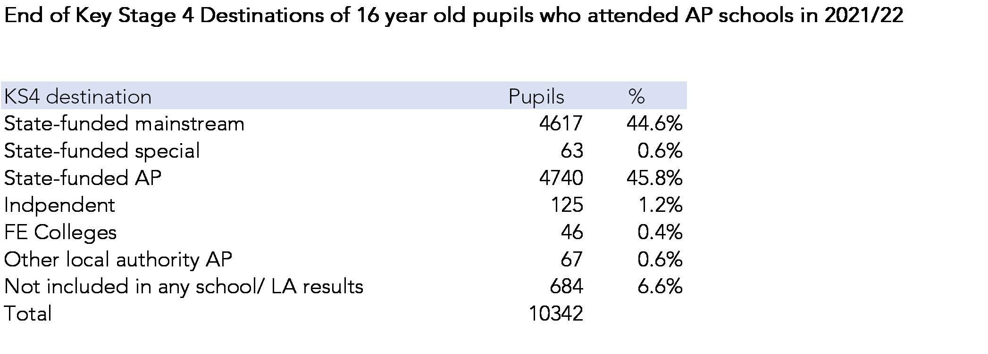
The 4,740 pupils counted against AP schools represent less than half (46%) of all 16 year old pupils who attended an AP school in 2021/22. The majority of the remainder (45% of the total) were recorded in the results of state-funded mainstream schools. Of the remaining 9.5%, two-thirds (684 pupils, 6.6%) had no observed destination at all.
This raises the question about which pupils should be included in performance measures for AP schools.
Options might include:
- Single-rolled (or main dual-rolled) pupils on roll in January of Year 11
- Single-rolled (or main dual-rolled) pupils on roll in January of Year 11 or later
- Single-rolled (or main dual-rolled) pupils on roll at any time in Year 11
- All pupils on roll at any time in Year 11
- All pupils on roll in January of Year 11
- All pupils on roll in January of Year 11 or later
Table 7 compares attainment measures for the group of 4,740 pupils included in KS4 Performance Tables data at AP schools to the group of 16 year old pupils who spent time in AP schools in 2021/22 but who were recorded at other types of school (or not recorded at any school).
Table 7: Key Stage 4 performance by destination, 2022
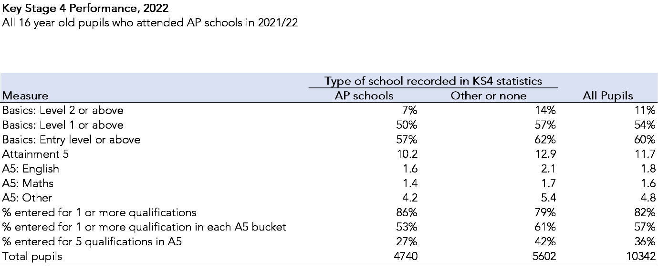
On the whole, pupils recorded at AP schools were slightly lower attaining although they were slightly more likely to be entered for at least one qualification.

Summary
Current measures published in Key Stage 4 Performance Tables do not adequately summarise the attainment of pupils who attend AP or special schools.
Suitable measures can be published provided that all approved qualifications are included in calculations, not just those currently considered in-scope of Performance Tables.
We have shown how broader measures of the basics- achievements in English/ literacy and maths/ numeracy- can be calculated that include a wider range of qualifications than just GCSEs.
We have also shown how to calculate a broad measure of Attainment- Attainment 5- and its value-added equivalent-Progress 5. This is a measure of attainment conditional on prior (Key Stage 2) attainment and calculated separately for AP schools and special schools.
Finally, we offer some thoughts about which pupils should be included in Key Stage 4 measures for AP schools that reflect the often transient nature of many pupil enrolments.

Annex A: Points scores in common qualifications
Qualification | GRADE | POINTS | SIZE
Functional Skill at Entry Level | 3 | 0.3750 | 0.5
Functional Skill at Entry Level | 2 | 0.2500 | 0.5
Functional Skill at Entry Level | 1 | 0.1250 | 0.5
Functional Skill at Level 1 | P | 1.0000 | 0.5
Functional Skill at Level 1 | F | 0.0000 | 0.5
Functional Skill at Level 2 | P | 3.2500 | 0.5
Functional Skill at Level 2 | F | 0.0000 | 0.5
BTEC First Award L1/2 - Band C - P-D* | *2 | 8.5000 | 1
BTEC First Award L1/2 - Band C - P-D* | D2 | 7.0000 | 1
BTEC First Award L1/2 - Band C - P-D* | M2 | 5.5000 | 1
BTEC First Award L1/2 - Band C - P-D* | P2 | 4.0000 | 1
BTEC First Award L1/2 - Band C - P-D* | P1 | 1.7500 | 1
BTEC First Award L1/2 - Band C - P-D* | U | 0.0000 | 1
OCR Cambridge National Award | *2 | 4.2500 | 0.5
OCR Cambridge National Award | D2 | 3.5000 | 0.5
OCR Cambridge National Award | M2 | 2.7500 | 0.5
OCR Cambridge National Award | P2 | 2.0000 | 0.5
OCR Cambridge National Award | D1 | 1.0000 | 0.5
OCR Cambridge National Award | M1 | 0.7500 | 0.5
OCR Cambridge National Award | P1 | 0.5000 | 0.5
OCR Cambridge National Award | U | 0.0000 | 0.5
OCR Level 1/2 Cambridge National Certificate | D2 | 7.0000 | 1
OCR Level 1/2 Cambridge National Certificate | M2 | 5.5000 | 1
OCR Level 1/2 Cambridge National Certificate | P2 | 4.0000 | 1
OCR Level 1/2 Cambridge National Certificate | D1 | 3.0000 | 1
OCR Level 1/2 Cambridge National Certificate | M1 | 2.0000 | 1
OCR Level 1/2 Cambridge National Certificate | P1 | 1.2500 | 1
OCR Level 1/2 Cambridge National Certificate | U | 0.0000 | 1
ELQ Band A | 3 | 0.1875 | 0.25
ELQ Band A | 2 | 0.1250 | 0.25
ELQ Band A | 1 | 0.0625 | 0.25
ELQ Band A | F | 0.0000 | 0.25
ELQ Band B | 3 | 0.3750 | 0.5
ELQ Band B | 2 | 0.2500 | 0.5
ELQ Band B | 1 | 0.1250 | 0.5
ELQ Band C | 3 | 0.7500 | 1
ELQ Band C | 2 | 0.5000 | 1
ELQ Band C | 1 | 0.2500 | 1
ELQ Band C | U | 0.0000 | 1
ELQ Band D | 3 | 1.5000 | 2
ELQ Band D | 2 | 1.0000 | 2
ELQ Band D | 1 | 0.5000 | 2
GCSE (9-1) Full Course | 9 | 9.0000 | 1
GCSE (9-1) Full Course | 8 | 8.0000 | 1
GCSE (9-1) Full Course | 7 | 7.0000 | 1
GCSE (9-1) Full Course | 6 | 6.0000 | 1
GCSE (9-1) Full Course | 5 | 5.0000 | 1
GCSE (9-1) Full Course | 4 | 4.0000 | 1
GCSE (9-1) Full Course | 3 | 3.0000 | 1
GCSE (9-1) Full Course | 2 | 2.0000 | 1
GCSE (9-1) Full Course | 1 | 1.0000 | 1
GCSE (9-1) Full Course | U | 0.0000 | 1
Pearson BTEC Level 2 Award in Home Cooking Skills | P | 3.2500 | 0.5
Pearson BTEC Level 1 Award in Home Cooking Skills | P | 0.5000 | 0.25
TCL Level 1 Award in the Arts | P | 0.5000 | 0.25
TCL Level 1 Award in the Arts | F | 0.0000 | 0.25
Pearson Edexcel Level 1 Award in Number and Measure | P | 1.0000 | 0.5
Pearson Edexcel Level 1 Award in Number and Measure | U | 0.0000 | 0.5
Pearson BTEC Level 1 Introductory Award in Sport | D | 1.5000 | 0.5
Pearson BTEC Level 1 Introductory Award in Sport | M | 1.0000 | 0.5
Pearson BTEC Level 1 Introductory Award in Sport | P | 0.5000 | 0.5

