Performance Measures for AP schools: Re-integration and post-16 destinations
In a companion report, we proposed a number of Key Stage 4 attainment measures that were suitable for Alternative Provision schools.
In this example, we propose three other performance measures: re-integration, post-16 destinations and absence.
The first is re-integration of pupils in Key Stage 3 (Years 7 to 9). To what extent do we observe them re-integrated into mainstream (or special) education after attending AP?
The second is post-16 destinations. To what extent do we see pupils who attended AP in Year 11 in sustained education the following year?
The third is absence. What are rates of absence in AP schools?
The calculation of re-integration and post-16 destinations follow similar principles even though they may appear to be qualitatively different measures on the surface. However, they both involve identifying pupils who attended AP in a given year and then observing their activity the following year.
This work contains statistical data from ONS which is Crown Copyright. The use of the ONS statistical data in this work does not imply the endorsement of the ONS in relation to the interpretation or analysis of the statistical data. This work uses research datasets which may not exactly reproduce National Statistics aggregates. The work was carried out in the Secure Research Service, part of the Office for National Statistics.

Data
We use three administrative data sources for this work: School Census and Absence from the National Pupil Database (NPD) and the Individualised Learner Record (ILR) linked to NPD.
School Census is a census of all pupils enrolled in state-funded schools in England. It is carried out every term, and also includes information on any pupils who leave a school between censuses.
ILR is a record of all students enrolled in FE Colleges, work-based learning providers and other providers of Further Education, including the qualifications for which they are studying.
We use School Census to identify all pupils who attend AP schools in a given year. For the purposes of this analysis, we use data from 2020/21 but recognize that numbers of enrolments were lower than in previous years due to the Covid-19 pandemic.
For pupils who were in Years 7 to 9 in 2020/21, we observe their enrolments in the 2021/22 academic year up to the Summer School Census (the middle of May).
Any pupils observed on roll of a mainstream or special school for at least 180 days or more is considered to have been re-integrated provided that no enrolments in AP schools are observed during that time. We also use the Local Authority Alternative Provision (LAAP) Census to identify any other placements outside the state-funded school sector although the limitation of this is that it is only observed once a year (in January).
For pupils who were in Year 11 in 2020/21, we observe both a) enrolments in schools and b) enrolments in colleges and other FE providers in 2021/22. Pupils who are observed to spend a continuous enrolment period of 180 days or more are considered to be in sustained education.
Absence data contains the number of absent sessions and the total number of possible sessions of attendance for each pupil at each school each year. We limit the dataset to records related to enrolments at AP schools.
We illustrate re-integration and post-16 destination measures with some worked examples.

Worked Examples: Re-integration
Pupil A spent time in an AP school as a dual-rolled pupil in 2020/21 having joined their mainstream school in September 2018. From March 2021 they returned full-time to the mainstream sector, in which they were enrolled continuously for the whole of 2021/22. They had no overlapping spells in AP schools in 2021/22 and so are considered to have been re-integrated.
Pupil | LAESTAB | Type of School | Entry Date | Leaving Date
A | 9994002 | Mainstream | 03/09/2018 | -
A | 9991102 | AP | 03/10/2020 | 24/03/2021

Pupil B also spent time in an AP school in 2020/21. They joined a mainstream school in September 2021 but continued to attend an AP school for a short period. They then had no further AP placements. For the purposes of calculating re-integration, we measure the time period between the last day they attended AP (22/10/2021) and the date of the Summer School Census (19/05/2022). As this is more than 180 days, Pupil B is also considered to have been re-integrated.
Pupil | LAESTAB | Type of School | Entry Date | Leaving Date
B | 9991103 | AP | 02/09/2020 | 22/10/2021
B | 9994002 | Mainstream | 06/09/2021 | -

Worked example: Post-16 destinations
Pupil C was on roll (in Year 11) at an AP school for the whole of 2020/21. They joined a mainstream school in September 2021 and remained on roll for the whole of 2021/22. For the purposes of the post-16 destination measure, they are considered to have been continuously in education for at least 180 days in 2021/22.
Pupil | LAESTAB | Type of School | Entry Date | Leaving Date
C | 9991103 | AP | 02/09/2020 | 16/07/2021
C | 9994002 | Mainstream | 06/09/2021 | -

Pupil D was also on roll in Year 11 at an AP school for the whole of 2020/21. They joined a FE College in September 2021 but left on the 1st October. They enrolled at another FE College in June 2022 and remained there until the end of the year. However, they do not spend a continuous period of at least 180 days in education in 2021/22.
Pupil | LAESTAB | Type of School | Entry Date | Leaving Date
D | 9991103 | AP | 02/09/2020 | 16/07/2021
D | 9998601 | FE College | 06/09/2021 | 01/10/2021
D | 9998602 | FE College | 05/06/2022 | -

Entry dates and leaving dates at colleges and other FE providers (such as work-based learning providers) aren’t directly observed in the Individualised Learner Record (ILR), the data source used to observe education and training in the FE sector. Instead, we observe start and end dates when learners are enrolled on learning aims (i.e. courses). We first collapse overlapping learning aims into learning spells, continuous periods of time in which learners are observed to be enrolled on at least one learning aim at an FE provider.

Worked Example: Absence
In the table below, we show some summary absence records for two pupils at two AP schools in 2021/22.
Pupil | LAESTAB | Type of School | Absences | Possible Sessions | % absence
E | 9991103 | AP | 45 | 70 | 64%
F | 9991103 | AP | 178 | 346 | 51%

Pupil E was a subsidiary-registered pupil and was expected to attend 70 sessions (half-days) at their AP school in 2021/22. They were absent for 45, hence have an absence rate of 64%.
Pupil F was single-rolled at their school and so was expected to attend 346 sessions (a full year at that particular school). They were absent for 178, an absence rate of 51%.
When calculating the overall absence rate for the school, we sum the total absences and divide by the total possible sessions. This means that pupil F would contribute a greater weight than pupil E to the school calculation since they were expected to attend more sessions.
However, the pupils contribute equally to persistent absence measures. Both pupils were absent for at least 50% of sessions at their AP school and so would be considered to be severe absentees.

Results: Re-integration
Re-integration rates for Key Stage 3 (Year 7 to Year 9) pupils on roll in state-funded AP schools in 2020/21 are presented in Table 1. These rates show the percentage of pupils who had been re-integrated back into mainstream or special schools during 2021/22.
Table 1: Re-integration rates of KS3 pupils by pupil characteristics, 2021/22
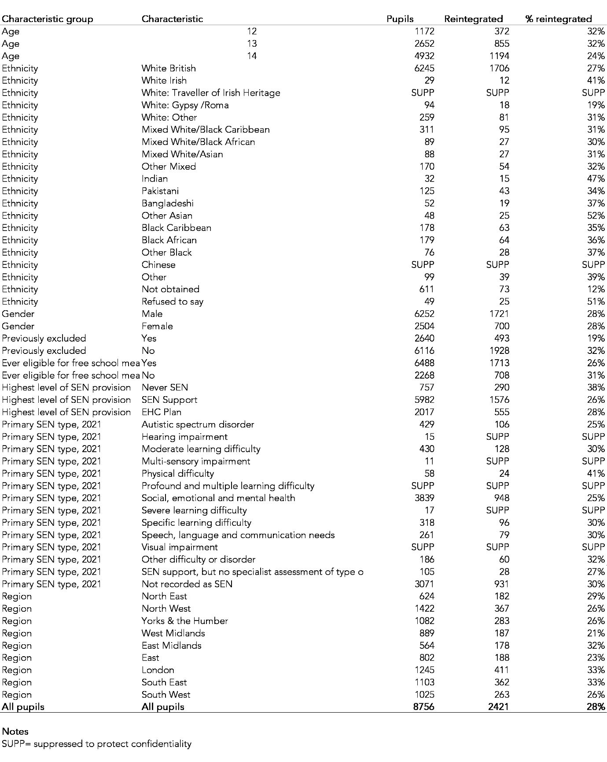
Overall, 28% of pupils are observed to have been re-integrated.
There are variations in this rate between groups of pupils. Older pupils (those aged 14, i.e. those of Year 9 age) were less likely (24%) than younger pupils (32%) to be re-integrated.
Pupils who had previously been permanently excluded and disadvantaged pupils were less likely to be re-integrated while those who had never previously been observed with special educational needs (SEN) were more likely to be re-integrated.
Re-integration rates of boys and girls were very similar although more boys were re-integrated since boys outnumber girls in the AP sector.

Results: Post-16 destinations
Post-16 destinations for pupils on roll in Year 11 in AP schools at any time during 2020/21 are shown in Table 2. This summarises destinations in the 2021/22 academic year.
Table 2: Post-16 destinations for Year 11 pupils by pupil characteristics, 2021/22
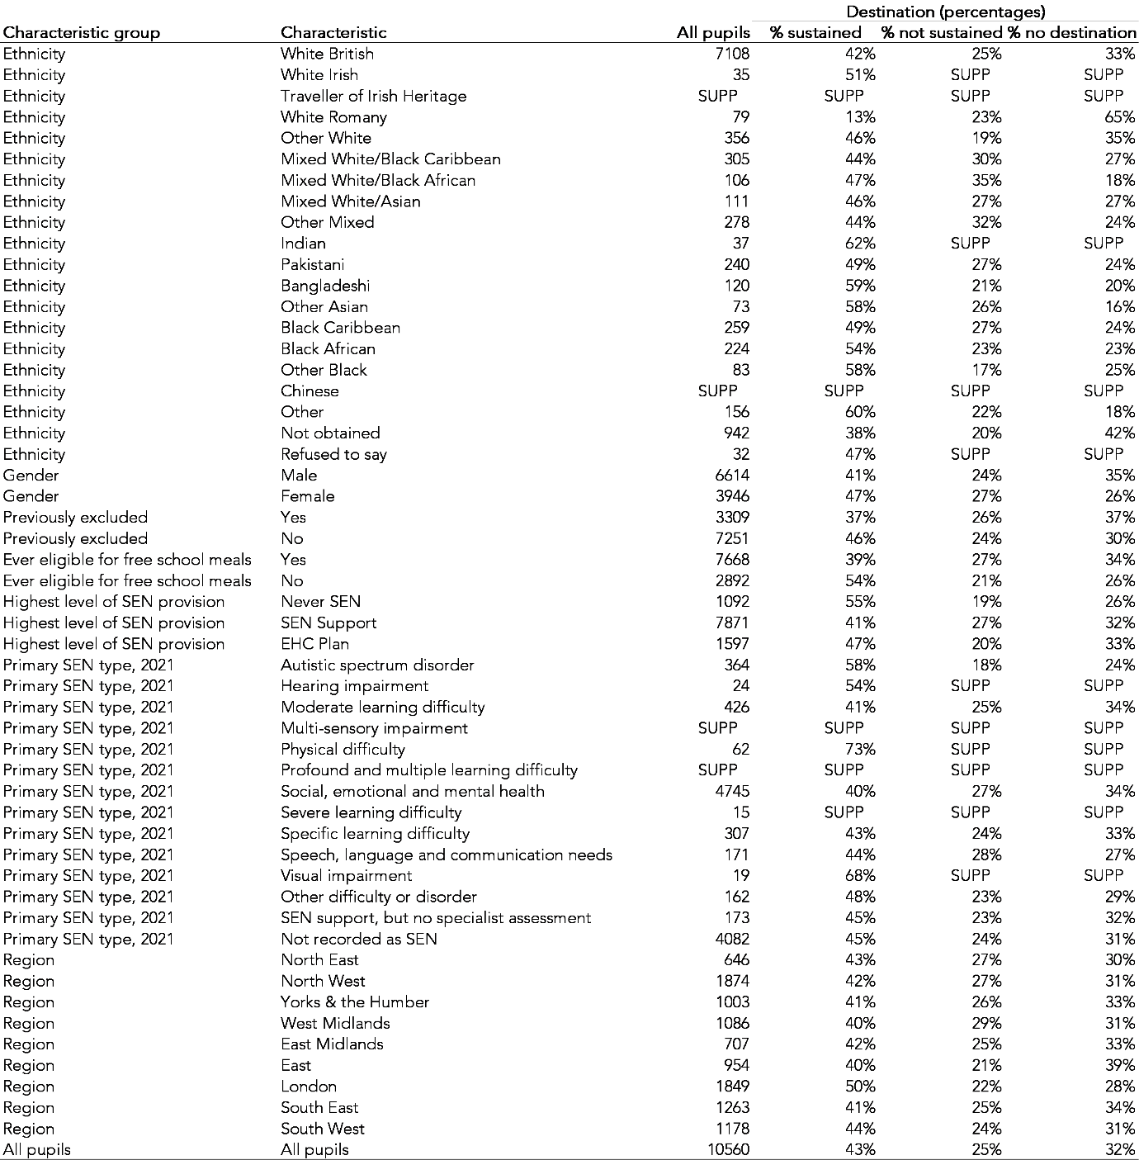
43% of pupils were observed to have a sustained post-16 destination, that is were enrolled at a school or FE provider for at least 180 days in 2021/22.
Rates vary between pupil groups. 54% of those never eligible for free school meals were observed in a sustained post-16 destination compared to 39% of those eligible at least once in their school career. 55% of those never observed to have SEN (itself a relatively small group) were observed in a sustained destination compared to 47% observed with an EHCP and 41% of those observed to have received support from their schools. Girls were slightly more likely than boys to be in sustained post-16 education. Rates were highest among pupils from AP schools in London.
Those not observed in sustained education fall into two groups: those who spend some time in post-16 education, but not for at least 180 days continuously, and those who never spend any time in post-16 education despite being required to remain in education until their 18th birthday.
The latter group outnumbers the former group. 32% of all Year 11 AP pupils are not observed to have a post-16 destination compared to 25% of all pupils who enter post-16 education but whose destination is not sustained.
In the chart below, we show the percentage of pupils enrolled in post-16 learning (whether sustained or not) on the first day of each month in the year following Year 11.
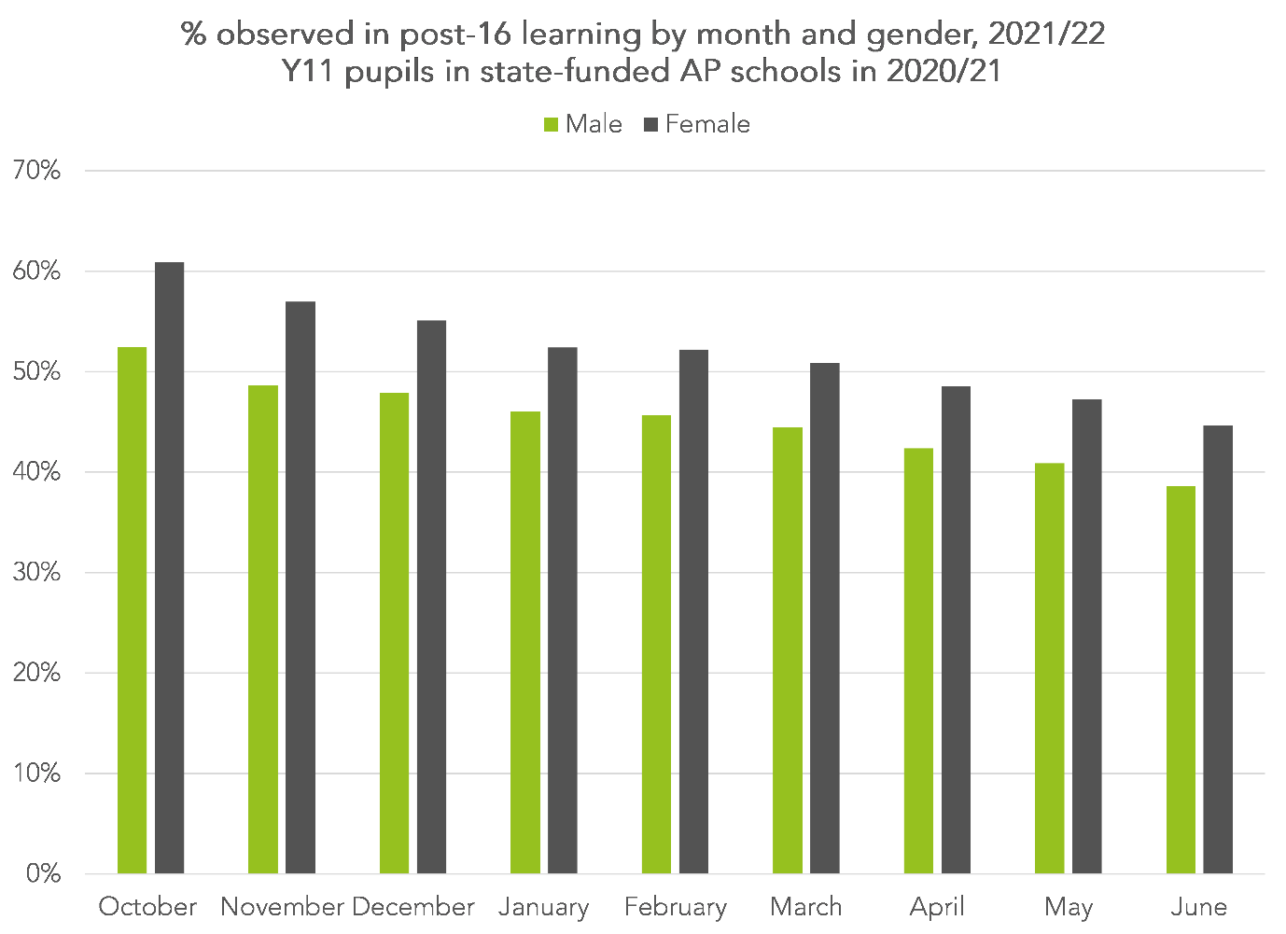
61% of girls and 52% of boys were observed in learning on the 1st October. However, these rates fell month-by-month during the rest of the year. By 1st June, 45% of girls and 39% of boys were observed in learning.

Results: Absence
Summary absence data for schools in the AP sector in 2021/22 is shown in Table 3.
Table 3: Absence in state-funded AP schools by pupil characteristics, 2021/22
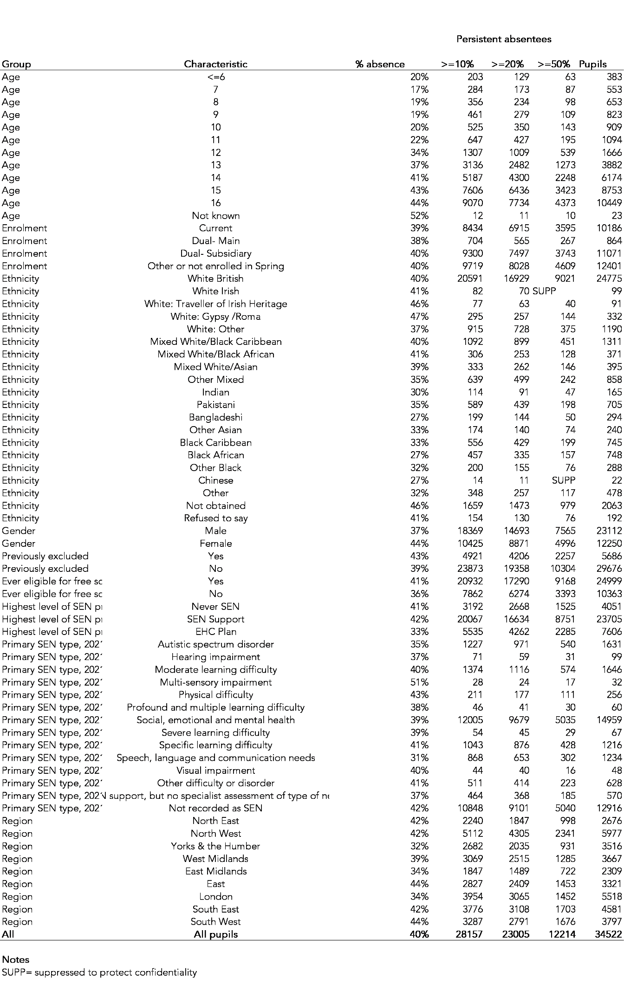
Overall, the absence rate in AP schools in 2021/22 was 40%. 82% of pupils were persistent absentees, that is to say missed at least 10% of the sessions they were expected to attend. 35% were severe absentees, missing at least 50% of sessions.
Propensity to be absent increases with age. Absence among primary-aged pupils is half that of those aged 14-16.
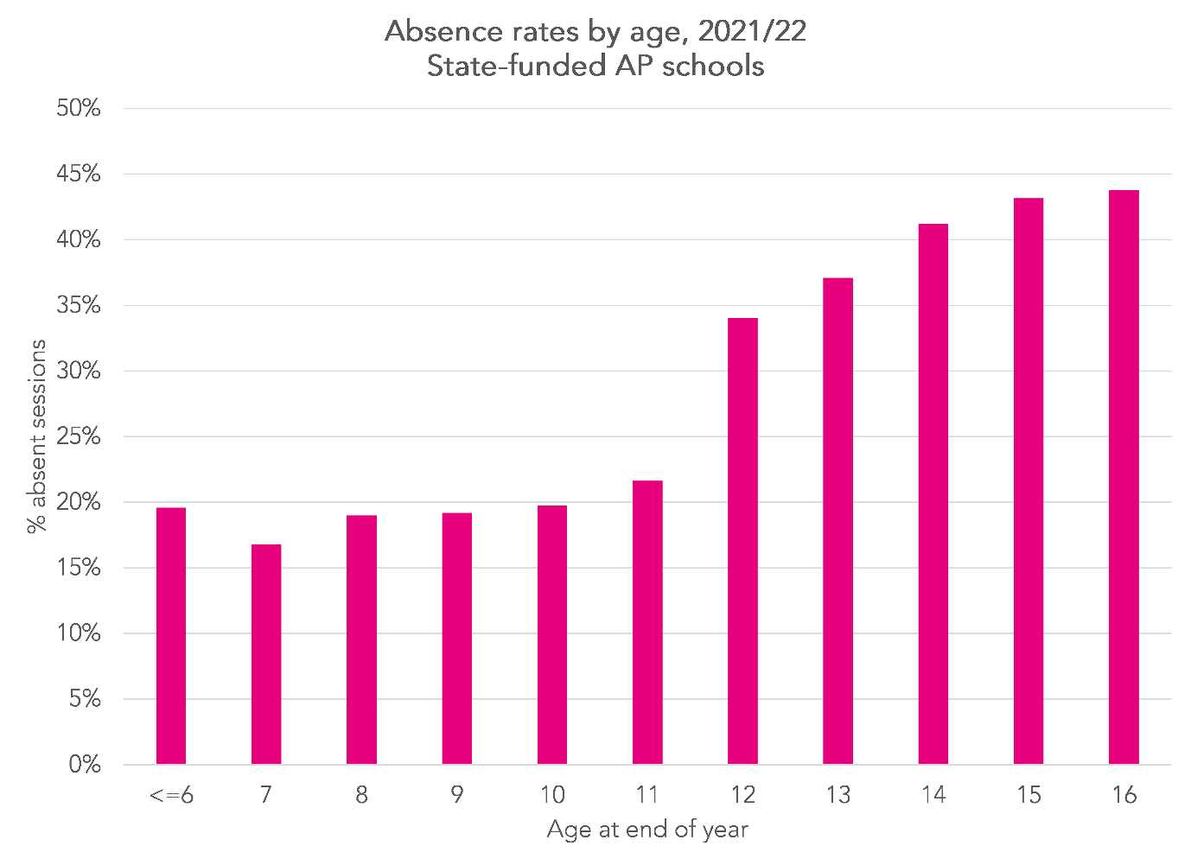
Absence rates were higher among boys, those who had been permanently excluded and pupils ever eligible for free school meals. Pupils with EHC plans were less likely to be absent than other pupils.
Yorkshire & the Humber was the region with the lowest absence rate. Absence was also relatively low in London and the East Midlands.

Summary
In this report, we have presented three indicators that could be published as part of a performance framework for state-funded AP schools alongside measures of attainment and qualification entry, which we show elsewhere.
These three indicators are:
- Absence (compulsory age pupils)
- Re-integration (KS3 pupils)
- Post-16 destinations (Year 11 pupils)
Statistics have been produced for the 2021/22 academic year, the most recent available data at the time of writing, but which we plan to update for 2022/23.
This is the first time that we have produced these statistics since the start of the Covid-19 pandemic. Referring back to our previous work shows a very slight increase in absence rates but post-16 destination rates are broadly similar to pre-pandemic times. The measure of re-integration we have developed here is a new one.
The outcomes we observe are rather poor. Pupils on roll in AP schools were absent for at least 40% of sessions in 2021/22. However, this isn’t to blame AP providers: they are often working with groups of troubled young people. The use of performance measures can help to build a case for further support and to evaluate the effectiveness of programmes to improve outcomes.
Less than half of young people who spend time in AP schools during Year 11 go on to sustained post-16 education. A third are never observed in post-16 education, though this may include a small number who have left the country. That notwithstanding, the fact we see around a third of AP pupils not engaging with post-16 education is a cause for concern. Further support is required to ensure transition between AP and post-16.
Beyond transition, further support is then required to ensure that young people remain in learning.

