Performance Measures for AP schools: 2023 Absence and Post-16 Destinations
In a previous article we set out some suggestions for developing a range of performance measures for Alternative Provision (AP) schools.
Firstly, we calculated a range of Key Stage 4 attainment measures, including Progress 5, based on all approved qualifications.
Secondly, we produced a range of other measures, including re-integration, post-16 destinations and absence.
We have updated the measures of attainment and re-integration using data for 2023..
In the rest of the article we present data on post-16 destinations and absence.

Data
We use three administrative data sources for this work: School Census and Absence from the National Pupil Database (NPD) and the Individualised Learner Record (ILR) linked to NPD.
School Census is a census of all pupils enrolled in state-funded schools in England. It is carried out every term, and also includes information on any pupils who leave a school between censuses.
ILR is a record of all students enrolled in FE Colleges, work-based learning providers and other providers of Further Education, including the qualifications for which they are studying.
We use School Census to identify all pupils who attend AP schools in a given year. For the purposes of this analysis, we use data from 2021/22.
For pupils who were in Year 11 in 2021/22, we observe both a) enrolments in schools and b) enrolments in colleges and other FE providers in 2022/23. Pupils who are observed to spend a continuous enrolment period of 180 days or more are considered to be in sustained education. We provide a worked example of this in our previous report.
Absence data contains the number of absent sessions and the total number of possible sessions of attendance for each pupil at each school each year. We limit the dataset to records related to enrolments at AP schools related to pupils of compulsory school age.

Absence
On average, pupils were absent for 42% of the sessions they were meant to attend at AP schools, equivalent to missing 2 days per week. This was slightly higher than the 40% we found when we ran the analysis on 2021/22 data.
As it does for pupils in mainstream schools, absence varied by age, with secondary-aged pupils being more likely to be absent.
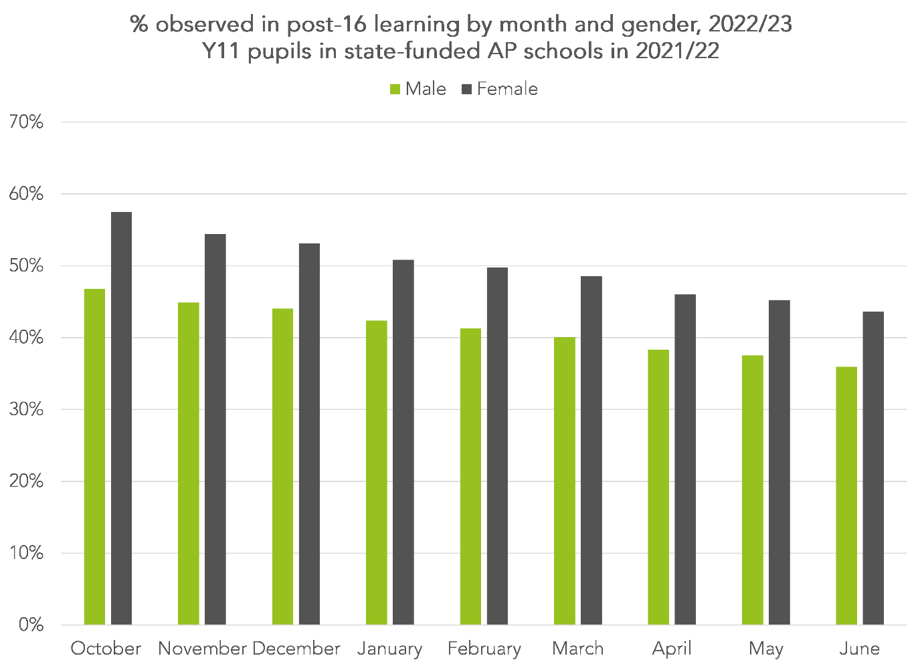
Further data is presented in Table 1 of the appendix.
Of particular note, and in contrast to mainstream schools, pupils with EHC plans are absent less often than other pupils attending AP schools who had never been identified as having special educational needs (SEN) during their school career.
38% of pupils who attend AP schools are severely absent, i.e. their rate of absence at AP schools is over 50%.

Post-16 destinations
Just 40% of pupils who completed Key Stage 4 at an AP school in 2021/22 were in sustained education at a school or college in 2022/23. This was down from 43% for the 2020/21 cohort.
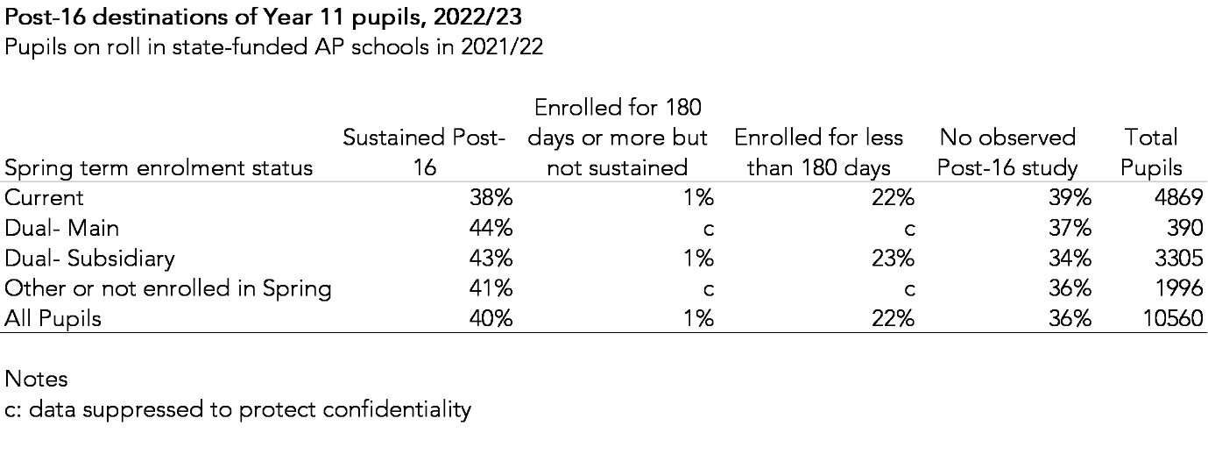
More concerningly, 36% do not appear to have enrolled at any school or college in England during 2022/23.
Boys, those who had been permanently excluded and those ever eligible for free school meals were less likely than other pupils to be in sustained in post-16 education (see TBL2 of the appendix).
The chart below shows the percentage of Y11 pupils from 2021/22 who were enrolled in post-16 study each month the following year.
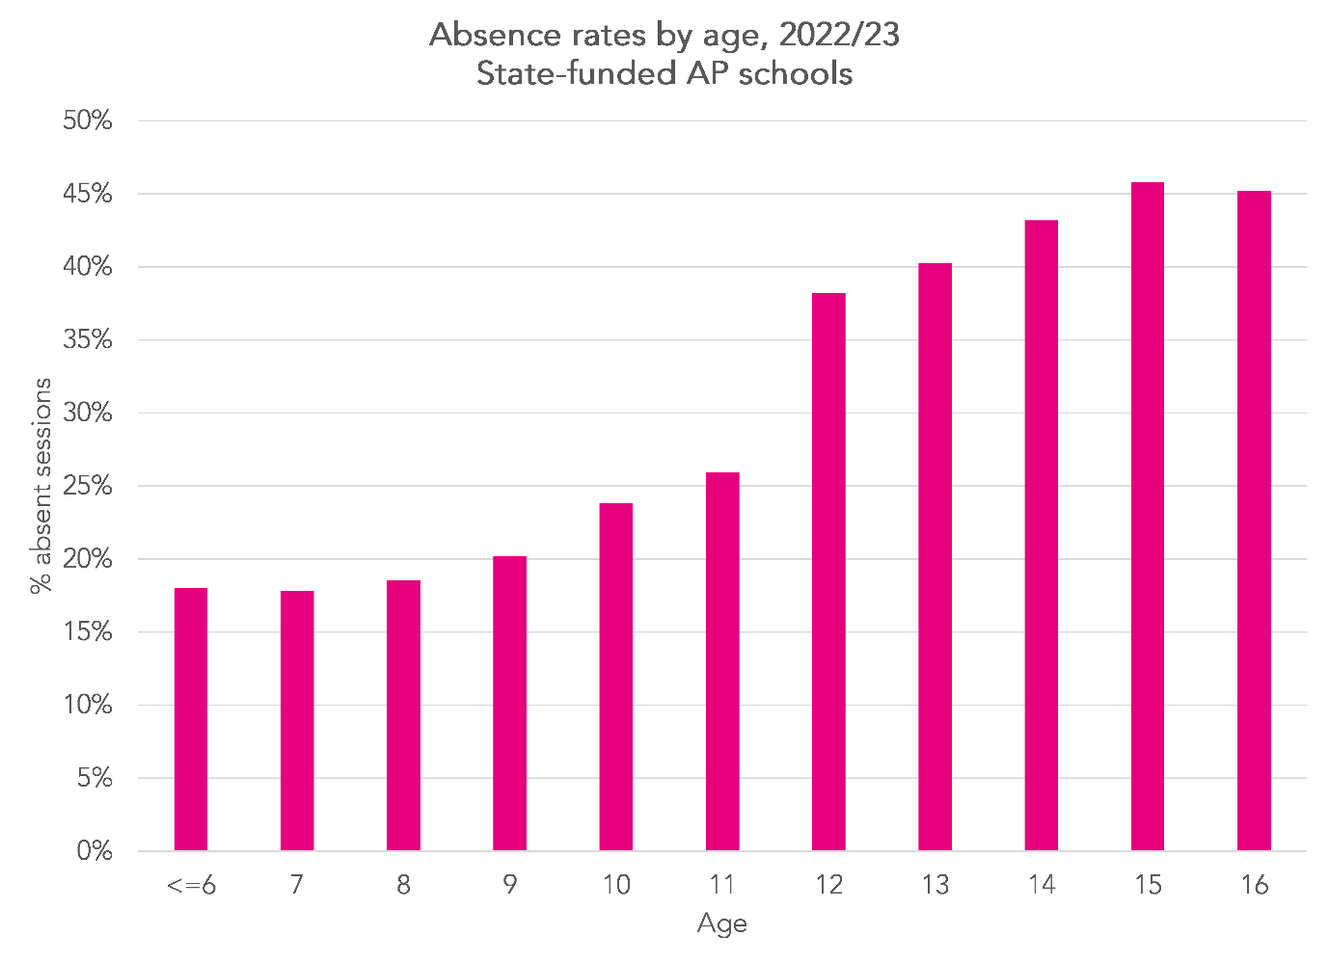
47% of boys and 58% of girls were enrolled in post-16 study in October. This fell to 36% and 44% respectively.

Summing up
The new government’s vision for alternative provision will no doubt become clearer over time. But taking action to improve outcomes such as absence and post-16 destinations is essential.
These are unlikely to be outcomes that are within AP schools’ gift to improve alone. The absence rate of over 40%, together with data on the characteristics of pupils attending AP schools, underlines the more complex needs of pupils who attend AP. Additional support services, such as those provided within Alternative Provision Specialist Taskforces will need to play a part.
Similarly, data on post-16 destinations suggests two hurdles: firstly, supporting pupils to make an initial transition to post-16 study and secondly supporting them to stay there until 18. This will involve working collaboratively with the FE sector.
[mailing_list_prompt]
[npd_ident_ons]

