Performance Measures for AP schools: Re-integration 2023
In a previous articles we set out some suggestions for developing a range of performance measures for Alternative Provision (AP) schools.
Firstly, we calculated a range of attainment measures, including Progress 5, based on all approved qualifications.
Secondly, we produced a range of other measures, including re-integration, post-16 destinations and absence.
In the rest of the article we look at the re-integration measure in more depth.

Data
We use data from the National Pupil Database (NPD), specifically termly School Census data.
School Census is a census of all pupils enrolled in state-funded schools in England. It is carried out every term, and also includes information on any pupils who leave a school between censuses.
We use School Census to identify all pupils who attend AP schools in a given year.
For pupils who were in Years 7 to 9 in 2021/22, we observe their enrolments in the following academic year (2022/23) up to the Summer School Census (the middle of May).
Any pupils observed on roll of a mainstream or special school for at least 180 days or more is considered to have been re-integrated provided that no enrolments in AP schools are observed during that time. We also use the Local Authority Alternative Provision (LAAP) Census to identify any other placements outside the state-funded school sector although the limitation of this is that it is only observed once a year (in January).
We do not calculate re-integration for pupils in Year 10 or Year 11.
It is less common for Year 10 pupils to be re-integrated.
In the case of Year 11 pupils, the reason for this is that they reach school-leaving age and, bar a few individuals who join school sixth forms, we would not expect them to be on roll in mainstream schools the following year. Instead we measure post-16 destinations. We will provide updated destination statistics later in the year.

Defining Re-integration
We illustrate how we define re-integration using some examples.
Pupil A spent time in an AP school as a dual-rolled pupil in 2020/21 having joined their mainstream school in September 2018. From March 2021 they returned full-time to the mainstream sector, in which they were enrolled continuously for the whole of 2021/22. They had no overlapping spells in AP schools in 2021/22 and so are considered to have been re-integrated.
Pupil | LAESTAB | Type of School | Entry Date | Leaving Date
A | 9994002 | Mainstream | 03/09/2018 | -
A | 9991102 | AP | 03/10/2020 | 24/03/2021

Pupil B also spent time in an AP school in 2020/21. They joined a mainstream school in September 2021 but continued to attend an AP school for a short period. They then had no further AP placements. For the purposes of calculating re-integration, we measure the time period between the last day they attended AP (22/10/2021) and the date of the Summer School Census (19/05/2022). As this is more than 180 days, Pupil B is also considered to have been re-integrated.
Pupil | LAESTAB | Type of School | Entry Date | Leaving Date
B | 9991103 | AP | 02/09/2020 | 22/10/2021
B | 9994002 | Mainstream | 06/09/2021 | -

Results
30% of Key Stage 3 (Year 7 to Year 9) pupils on roll in state-funded AP schools in 2021/22 were re-integrated into mainstream by May of the following year.
This was slightly higher than the previous year (28%) although that cohort was more affected by the Covid-19 pandemic: 11,300 KS3 pupils attended AP schools in 2021/22 compared to 8,800 in 2020/21.
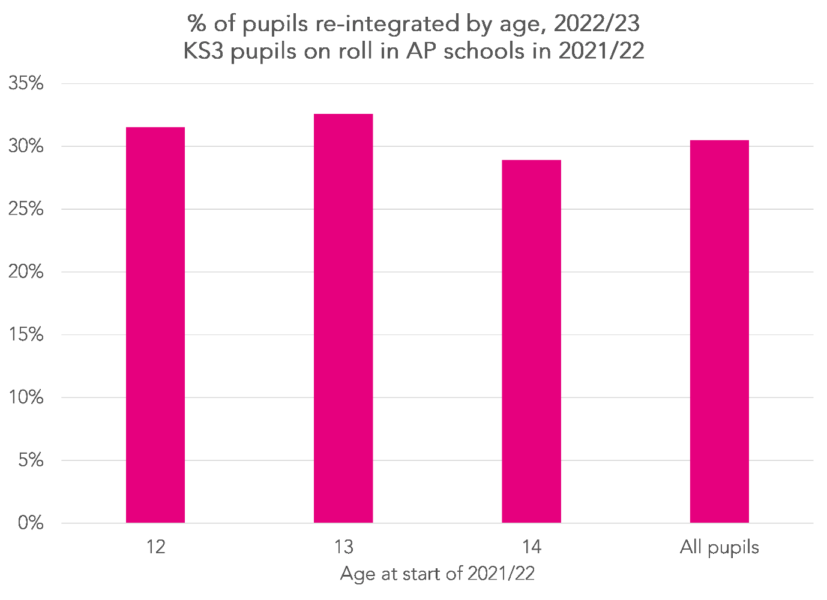
Older pupils (those aged 14, i.e. those of Year 9 age) were slightly likely (29%) than younger pupils (32% for Year 7 and 33% for Year 8) to be re-integrated.
5,900 of the 11,300 (52%) KS3 pupils were on roll when the January School Census was taken in 2022.
Those who had a dual-subsidiary registration (i.e. attended an AP school part-time) were more likely to be re-integrated. In other words, the AP placement could have been a short-term placement. Pupils with a current enrolment status (i.e. those who attended an AP school full-time) were less likely to be re-integrated.
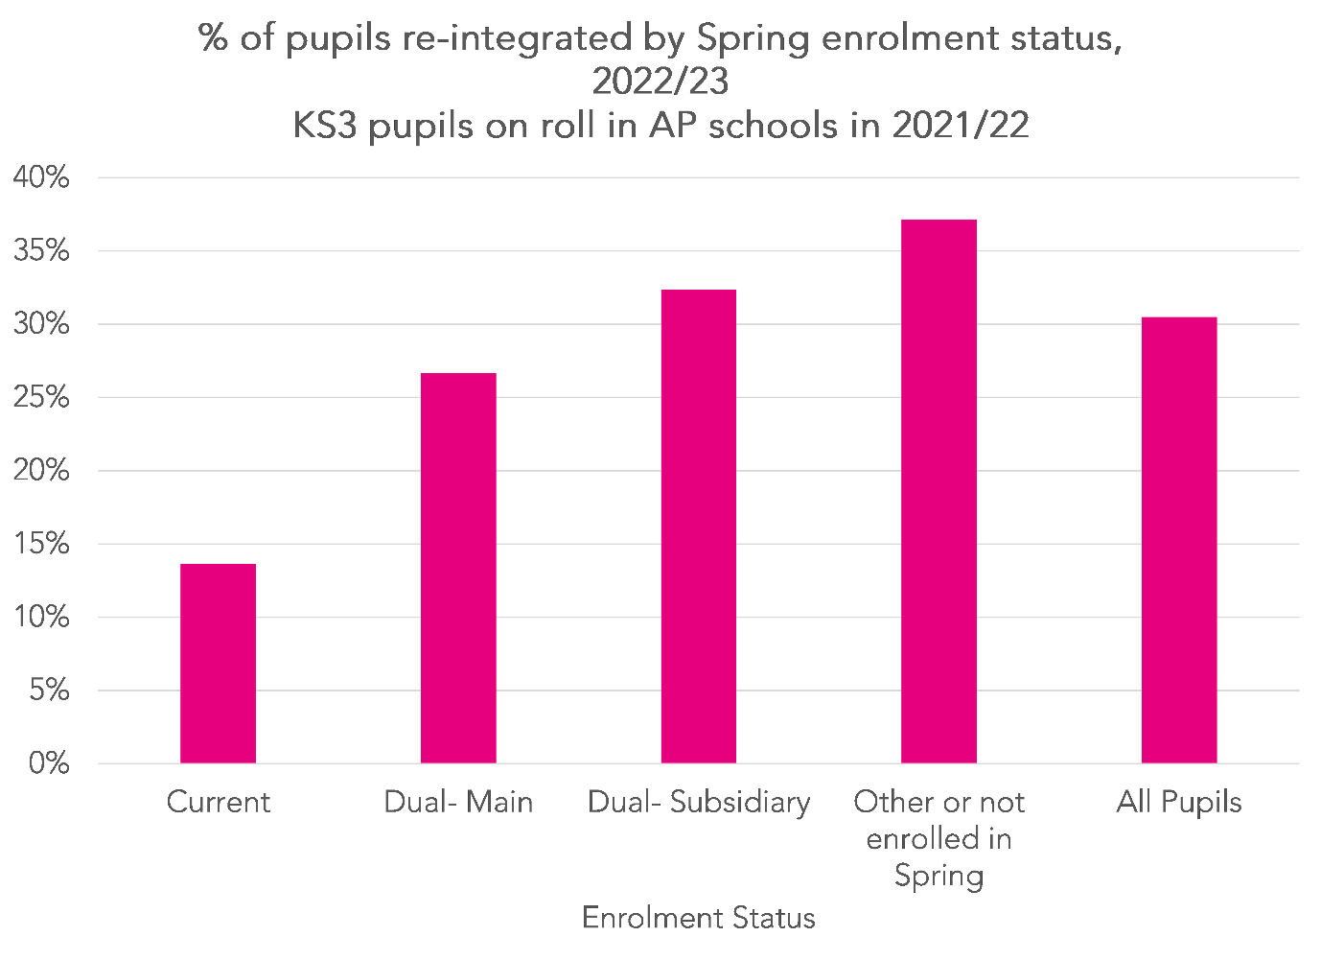
Pupils who had previously been permanently excluded and disadvantaged pupils were less likely to be re-integrated while those who had never previously been observed with special educational needs (SEN) were more likely to be re-integrated.
Re-integration rates of boys and girls were very similar although more boys were re-integrated since boys outnumber girls in the AP sector.
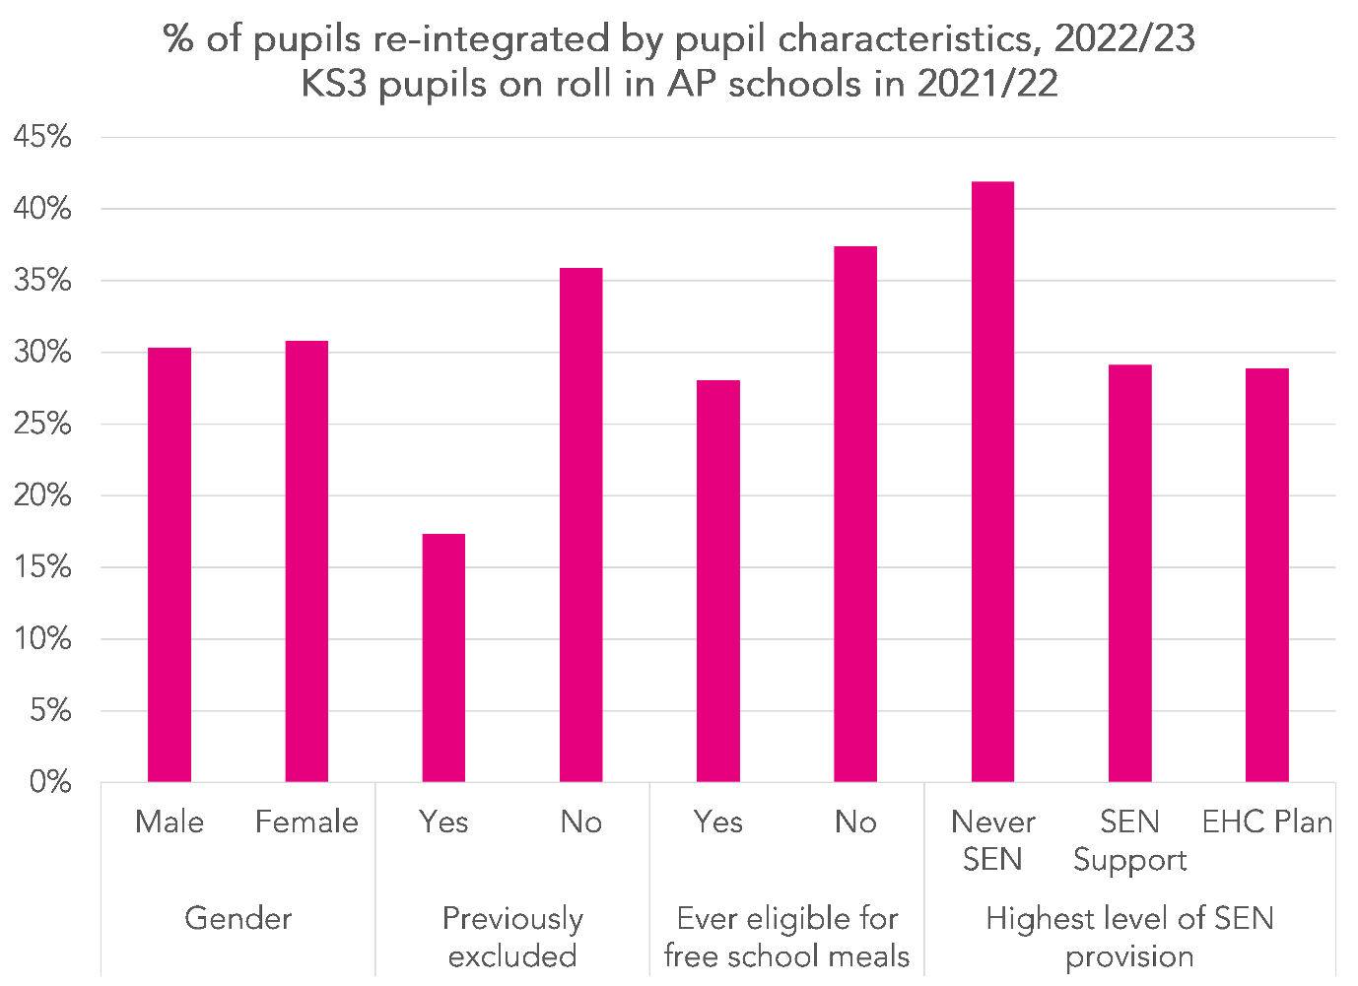
Further breakdowns by primary SEN type, ethnic background and region of residence are in the annex.

Summary
Using our measure of re-integration, around 30% of KS3 pupils who were on roll in the AP sector in 2021/22 were found to have been re-integrated into mainstream schools the following year.
At present, our measure is based upon being observed to be continuously enrolled at a state-funded mainstream school without any overlapping spells at state-funded AP schools or in alternative provision outside the state-funded sector where the local authority is paying fees.
One development we would like to make in future is to discount any overlapping spells at independent AP settings arranged (and paid for) by the mainstream school. This data is now collected via School Census but was unavailable to us for the purposes of this exercise. It may also be possible to infer this using “code B” (educated off-site) attendance codes.

